Contents

1. Lidar Obstacle Detection 4

1.1 Introduction to Lidar and Point Clouds 4

1.1.1 Lidar Sensors 4

1.1.2 Point Clouds 5

1.1.3 The PCL Library 6

1.1.4 ff 7

1.1.5 gg 7

1.1.6 hh 7

1.1.7 ff 7

1.1.8 gg 7

1.1.9 7

1.1.10 ff 7

1.1.11 gg 7

1.1.12 7

1.1.13 ff 7

1.1.14 gg 7

1.2 Point Cloud Segmentation 7

1.2.1 Heading 7

1.2.2 Placeholder 7

1.3 Clustering Obstacles 7

1.3.1 Heading 7

1.3.2 Placeholder 7

1.4 Working with Real PCD 7

1.4.1 Heading 7

1.4.2 Placeholder 7

1.5 Lidar Obstacle Detection Project 7

1.5.1 Heading 7

1.4.2 Placeholder 7

2. Radar 7

2.1 Radar Principles 7

2.1.1 The Radar Sensor 7

2.1.2 Signal Properties 10

2.1.3 FMCW 11

2.1.4 FMCW Hardware and Antenna 12

2.1.5 Radar Cross Section 14

2.1.6 Radar Range Equation 16

2.1.7 Placeholder 17

2.2 Range-Doppler Estimation 18

2.2.1 Range, Velocity and Angle Resolution 18

2.2.2 Range Estimation 18

2.2.3 Doppler Estimation 20

2.2.4 Fast Fourier Transform 22

2.2.5 The 2D FFT 24

2.2.6 Placeholder 25

2.3 Clutter, CFAR, AoA 26

2.3.1 Clutter 26

2.3.2 CFAR 27

2.3.3 CA-CFAR 28

2.3.4 CFAR 2D 29

2.3.5 Angle of Arrival 30

2.4 Clustering and Tracking 32

2.4.1 Clustering 32

2.4.2 Kalman Tracking 33

2.5 Radar Target Generation and Detection 34

2.5.1 Radar Target Generation and Detection 34

2.5.2 Placeholder 38

2.6 Placeholder 38

3. Camera 38

3.1 Autonomous Vehicles and Computer Vision 38

3.1.1 Levels of Autonomous Driving 38

3.1.2 Autonomous Vehicle Sensor Sets 40

3.1.3 Camera Technology Overview 46

3.1.4 The OpenCV Computer Vision Library 53

3.2 Engineering a Collision Detection System 55

3.2.1 Collision Detection Basics 55

3.2.2 Estimating TTC with Lidar 57

3.2.3 Estimating TTC with Camera 61

3.2.4 Course Structure 65

3.2.5 Early Fusion vs. Late Fusion 65

3.2.2 Placeholder 65

3.3 Tracking Image Features 65

3.3.1 Heading 1 65

3.3.2 Placeholder 65

3.4 Camera Based 2D Feature Tracking 65

3.4.1 Heading 1 65

3.4.2 Placeholder 65

3.5 Combing Camera and Lidar 65

3.5.1 Heading 1 65

3.5.2 Placeholder 65

3.6 Track an Object in 3D Space 65

3.6.1 Heading 1 65

3.5.2 Placeholder 65

3.7 Placeholder 65

Sensor Fusion Nanodegree

# Lidar Obstacle Detection

## Introduction to Lidar and Point Clouds

### Lidar Sensors

Lidar sensing gives us high resolution data by sending out thousands of laser signals. These lasers bounce off objects, returning to the sensor where we can then determine how far away objects are by timing how long it takes for the signal to return. Also we can tell a little bit about the object that was hit by measuring the intensity of the returned signal. Each laser ray is in the infrared spectrum, and is sent out at many different angles, usually in a 360 degree range. While lidar sensors gives us very high accurate models for the world around us in 3D, they are currently very expensive, upwards of $60,000 for a standard unit.

* The Lidar sends thousands of laser rays at different angles.
* Laser gets emitted, reflected off of obstacles, and then detected using a receiver.
* Based on the time difference between the laser being emitted and received, distance is calculated.
* Laser intensity value is also received and can be used to evaluate material properties of the object the laser reflects off of.

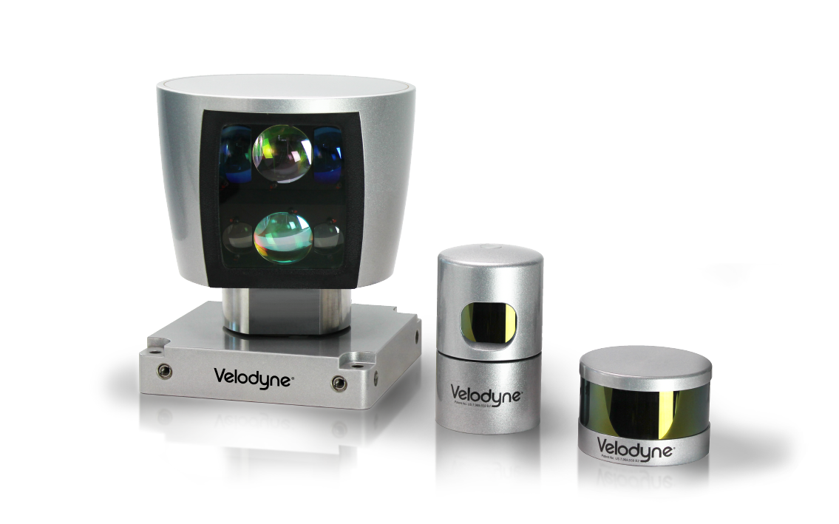

Velodyne lidar sensors, with HDL 64, HDL 32, VLP 16 from left to right. The larger the sensor, the higher the resolution

Here are the specs for a HDL 64 lidar. The lidar has 64 layers, where each layer is sent out at a different angle from the z axis, so different inclines. Each layer covers a 360 degree view and has an angular resolution of 0.08 degrees. On average the lidar scans ten times a second. The lidar can pick out objects up to 120M for cars and foliage, and can sense pavement up to 50M.

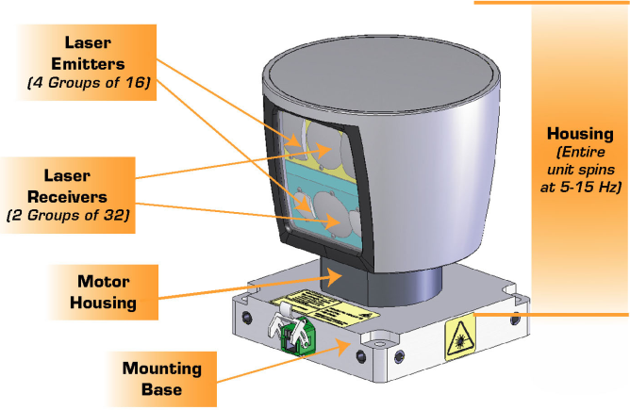

VLP 64 schematic, showing lidar emitters, receivers, and housing.

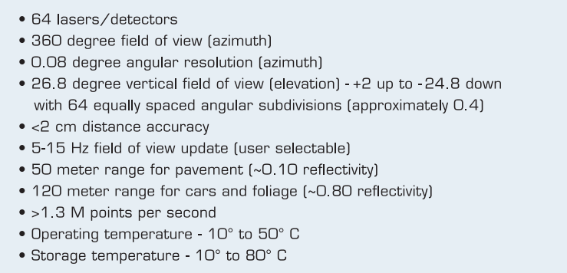

VLP Sensor Specifications

### Point Clouds

**PCD Files**

Let’s dive into how lidar data is stored. Lidar data is stored in a format called Point Cloud Data (PCD for short). A .pcd file is a list of (x,y,z) cartesian coordinates along with intensity values, it’s a single snapshot of the environment, so after a single scan. That means with a VLP 64 lidar, a pcd file would have around 256,000 (x,y,z,i) values.

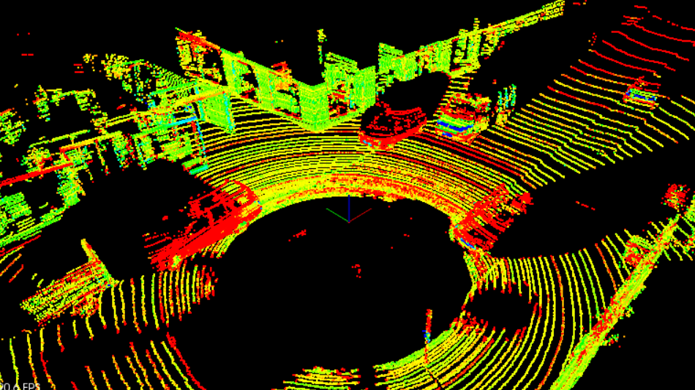

PCD of a city block with parked cars, and a passing van. Intensity values are being shown as different colors. The big black spot is where the car with the lidar sensor is located

**PCD Coordinates**

The coordinate system for point cloud data is the same as the car’s local coordinate system. In this coordinate system the x axis is pointing towards the front of the car, and the y axis is pointing to the left of the car. Also since this coordinate system is right-handed the z axis points up above the car.

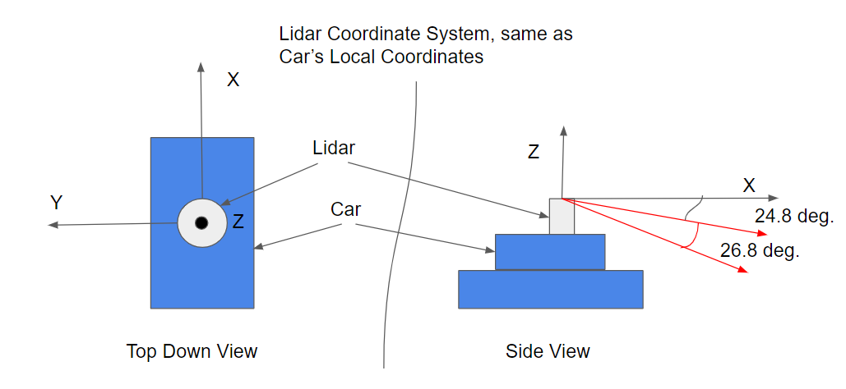

### The PCL Library

In this module you will be working on processing point cloud data to find obstacles. All the code will be done in a C++ environment, so some familiarity with C++ will definitely be helpful. PCL is an open source C++ library for working with point clouds. You will be using it to visualize data, render shapes, and become familiar with some of its built in processing functions. Some documentation for PCL can be found [here](http://pointclouds.org/).

PCL is widely used in the robotics community for working with point cloud data, and there are many tutorials available online for using it. There are a lot of built in functions in PCL that can help to detect obstacles. Built in PCL functions that will be used later in this module are Segmentation, Extraction, and Clustering.

### The Course Starter Code

All the code for doing lidar obstacle detection is contained in a GitHub repository. The classroom has workspace environments that already include all the dependencies for getting started right way. You can also clone the repo, and use the README to get started on your own machine as well. Here is the [link](https://github.com/udacity/SFND_Lidar_Obstacle_Detection).

You will mostly be working out of two main files, which are environment.cpp and processPointClouds.cpp. The environment.cpp file contains the main function and will generate the runnable executable. The processPointClouds.cpp file will contain all your function placeholders to process the pcd.

There are some other files worth mentioning, like sensors/lidar.h, which simulates lidar sensing and creates point cloud data. Also render.cpp and render.h which have functions for rendering objects onto the screen.

**Code Structure**

* Top-level CMakeLists.txt
* Readme
* src
  + render
    - box.h - this file has the struct definitions for box objects
    - render.h
    - render.cpp - this file, along with the header, define the classes and methods for rendering objects.
  + sensors
    - data - this directory contains pcd data used in the course.
    - lidar.h - has functions using ray casting for creating pcd.
* environment.cpp - the main file for using pcl viewer and processing and visualizing pcd.
* processPointClouds.h
* processPointClouds.cpp - Functions for filtering, segmenting, clustering, boxing, loading, and saving pcd.

### Compiling the Lidar Simulator

**Compilation Instructions**

* In the terminal workspace below, make sure that GPU is enabled.
* Click on Desktop button on lower right.
* Click on Terminator to load up work space desktop terminal.
* From the terminal, go to the project root directory, cd /home/workspace/SFND-Lidar-Obstacle-Detection.
* Create a new directory from the project root named build with the following command: mkdir build.
* Then go into the build directory: cd build.
* Run cmake pointing to the CMakeLists.txt in the root: cmake ... If everything went well you should see something like
  + Configuring done
  + Generating done
  + Build files have been written to: /your directory/simple_highway/build
* If cmake was successful, then from inside build run make: make
* If make built target environment 100%, it will have generated an executable called environment. This build process is defined from the CMakeLists.txt file.

### Running the Simulator

**Instructions**

Once you have built an executable file, you can lunch it by doing ./environment. Now you should see a window popping up that looks like the image above.

Here you have a simple highway simulator environment with the ego car in green in the center lane (that’s your car), and the other traffic cars in blue. Everything is rendered using PCL with simple boxes, lines, and colors. You can move around your environment with the mouse. Try holding the left mouse button to orbit around the scene. You can also pan around the scene by holding the middle mouse button and moving. To zoom, use the middle scroll mouse button or the right mouse button while moving.

**Recap**

* Using terminator in the virtual desktop, run the executable from the build directory using ./environment.
* You should see a 3D popup window with the road and cars.
* You can move around the environment.
* Zoom: hold the right mouse key and move the mouse forward/backwards, or use your mouse scroller.
* Pan: Hold down the middle mouse button (the scroller) and move the mouse.
* Rotate: Hold the left mouse button and move the mouse.

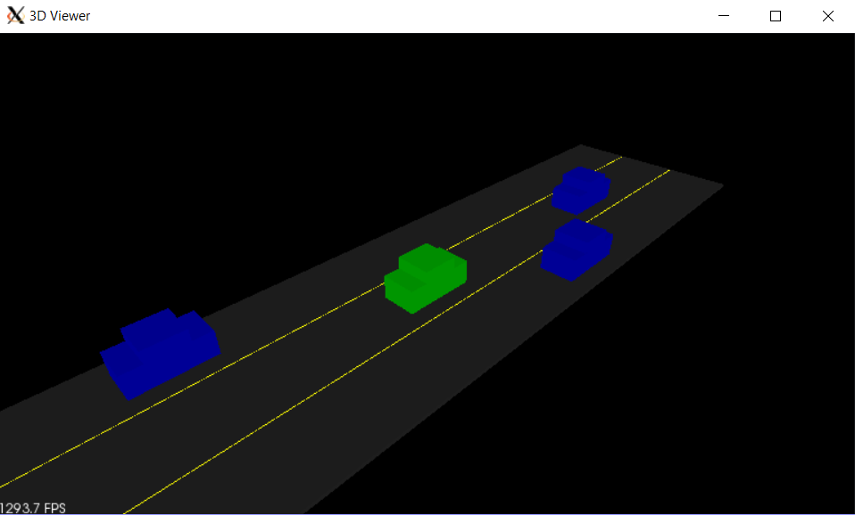

### The PCL Viewer

**PCL Viewer Overview**

In environment.cpp a pcl viewer is created. The viewer is used to handle all your visualization of objects on the screen. Some functions that use the pcl viewer inside environment.cpp are initCamera and initHighway. The initCamera function helps you set up different viewing angles in your window. There are five different options: XY, TopDown, Side, and FPS. XY gives a 45 degree angle view, while FPS is First Person Sense and gives the sensation of being in the car’s driver seat.

Also, the functions from render heavily use the viewer as well. You might notice that viewer is usually passed in as a reference. That way the process is more streamlined because something doesn't need to get returned.

### Creating the Lidar Object

The first thing you are going to do is create a lidar object. The lidar object is defined by the src/sensors/lidar.h header file which is included at the top of environment.cpp. Also in environment.cpp is the simpleHighway function, which takes a reference argument for the PCL visualizer viewer that was discussed previously.

**Exercise Instructions**

You will instantiate a pointer to a Lidar object in the simpleHighway function. You should create the Lidar pointer object on the heap, using the new keyword. The Lidar constructor takes two arguments: cars and the slope of the ground - these arguments are necessary for modeling ray collisions. The Lidar object should be created with a slope of 0.

**Note**

The lidar arguments are necessary for modeling ray collisions. The Lidar object is going to be holding point cloud data which could be very large. By instatinating on the heap, we have more memory to work with than the 2MB on the stack. However, it takes longer to look up objects on the heap, while stack lookup is very fast.

### gg

### 

### ff

### gg

### 

### ff

### gg

## Point Cloud Segmentation

### Heading

### 1.2.2 Placeholder

## Clustering Obstacles

### Heading

### 1.3.2 Placeholder

## Working with Real PCD

### Heading

### 1.4.2 Placeholder

## Lidar Obstacle Detection Project

### Heading

### 1.4.2 Placeholder

### 

# Radar

## Radar Principles

### The Radar Sensor

The image below shows how radar sensors are used along with a full suite of other sensors in an autonomous vehicle:

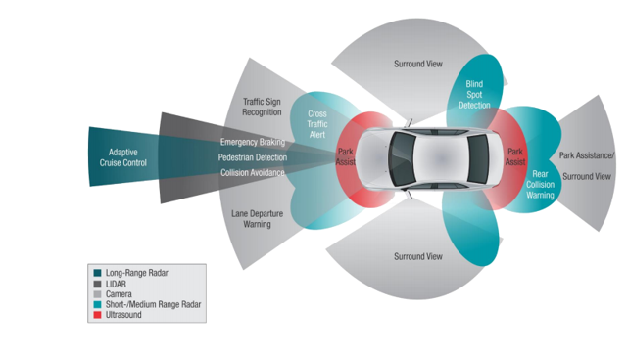

**Radar Operation**

Radar works using the transmission and detection of electromagnetic waves as seen in the following image:

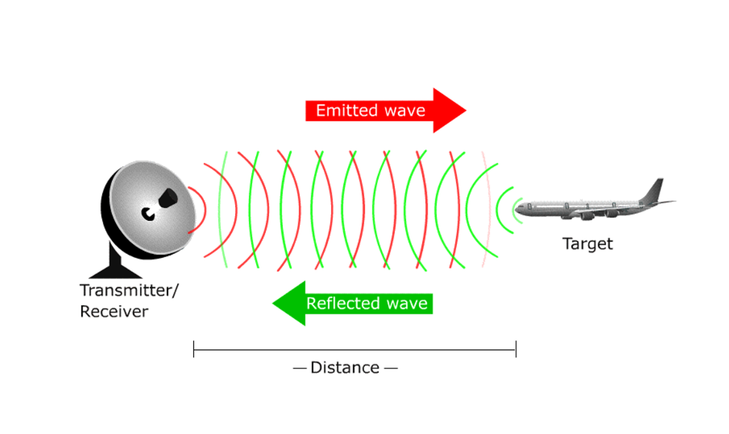

The electromagnetic waves are reflected if they meet an obstacle. If these reflected waves are received again at the place of their origin, then that means an obstacle is in the propagation direction. The frequency of electromagnetic energy used for radar is unaffected by darkness and also penetrates fog and clouds. This permits radar systems to determine the position of road targets that are invisible to the naked eye because of distance, darkness, or weather. Modern radar can extract widely more information from a target's echo signal than its range.

**Radar Construction**

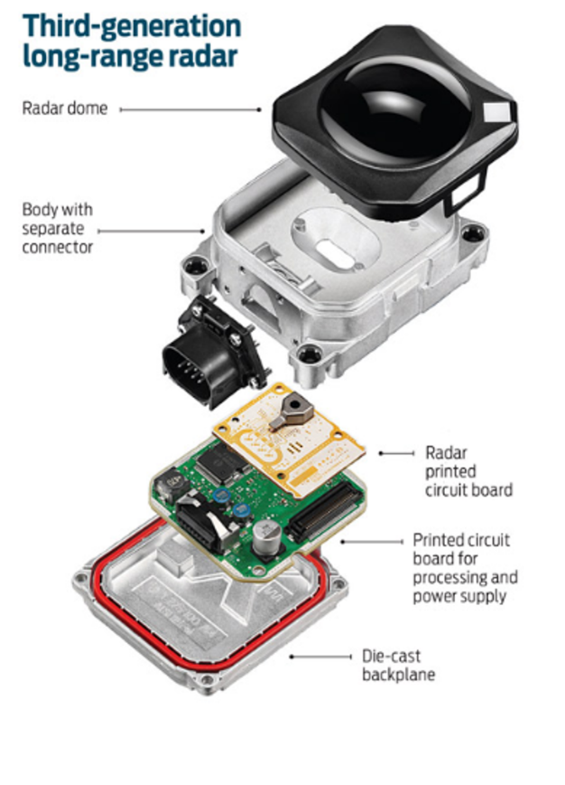

The automotive radars are small size sensors that can easily fit beneath the front grill or the bumper. As seen in the image above a radar module comprises of different parts.

*Radar Dome or Radome*: A radome is a structural, weatherproof enclosure that protects a radar antenna. The radome is constructed of material that minimally attenuates the electromagnetic signal transmitted or received by the antenna, effectively transparent to radio waves.

*Radar Printed Circuit Board*: This is analog hardware that includes the radar transceiver and antenna needed for radio wave generation.

*Printed Circuit Board and Processing*: This includes the Digital Signal Processing (DSP) unit.

**Radar vs Lidar**

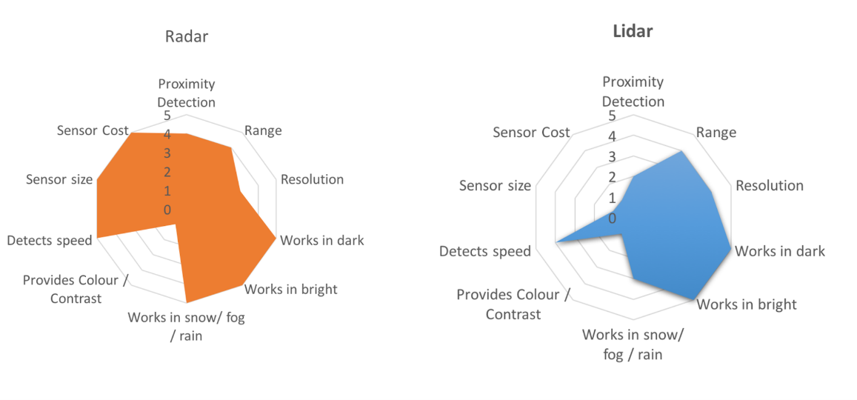

LIDAR can generate high resolution imaging based on reflection of the laser light off from the targets. But LIDARs fail in bad weather conditions as the very small wavelength doesn’t allow to work well in fog or rain. Additionally, LIDAR is an expensive sensor with costs varying from $35,000 to $100,000 as of 2019.

Radar lacks the capability to generate a high resolution image, but it has highly accurate velocity estimation based on the doppler phenomenon. Also, radar wavelength allows it to sense the targets in bad weather conditions as well. Most important is the low manufacturing cost for a Radar. A radar unit can cost as low as a few hundred dollars, allowing a car manufacturer to deploy multiple Radar sensors for 360 degree perception.

### Signal Properties

**Signal Wave Parameters**

Wavelength (λ) is the physical length from one point of a wave to the same point on the next wave, and it is calculated as

λ = $\frac{speed of light}{frequency}$

The higher the frequency the smaller the wavelength.

The *frequency* of a wave is the number of waves that pass by each second, and is measured in Hertz (Hz). The automotive radar generally operates at W band (76GHz - 81GHz). The signal at this frequency is referred to as millimeterWave since the wavelength is in mm.

The *Bandwidth* of a signal is the difference between the highest and the lowest frequency components in a continuous band of frequencies.

The *Amplitude* is the strength of the signal. Often it corresponds to the power of the RF signal/electromagnetic field defined in dB/dBm. It is relevant while configuring the output power of the radar and sensing the received signal. Higher the amplitude of the Radar signal, more is the visibility of radar. Automotive Radar can operate at max of 55 dBm output power (316 W)

**Phase of a Signal**

Phase is a particular point in time on the cycle of a waveform, measured as an angle in degrees. A complete cycle is 360°. The phase for each argument value, relative to the start of the cycle, is shown in the image below, in degrees from 0° to 360° and in radians from 0 to 2π.

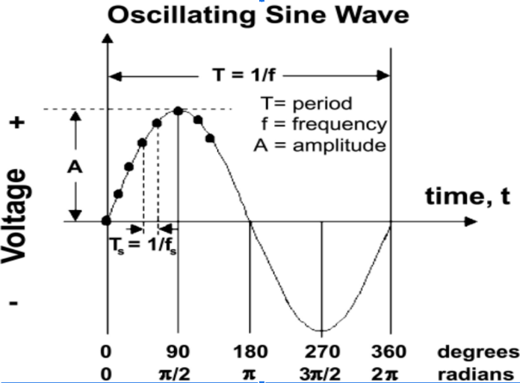

The frequency can also be defined as the first derivative of the phase with respect to the time.

$frequency= \frac{dφ}{dt}$ where $φ=phase of the signal$

The difference between the phases of two periodic signals is called the phase difference. At values of when the difference is zero, the two signals are said to be in phase, otherwise they are out of phase with each other.

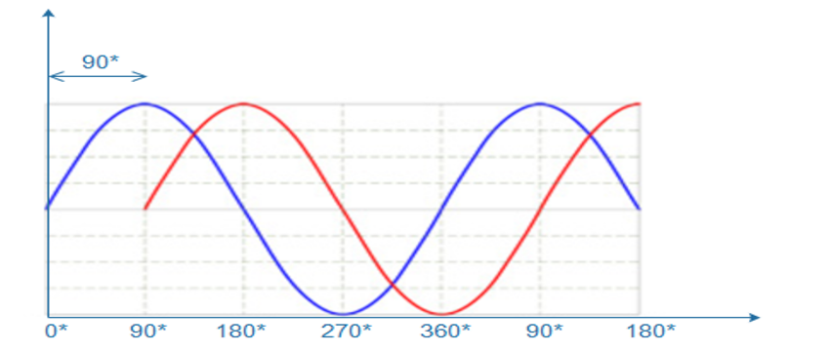

**General Equation of a Wave**

A wave travelling in space is defined by the following equation:

$y\left(t\right)=A cos⁡(2π*f_{c}*t+ φ)$

### FMCW

FMCW radar (Frequency-Modulated Continuous Wave radar) is a special type of radar sensor which radiates continuous transmission power. FMCW radar’s ability to measure very small ranges to the target as well as its ability to measure simultaneously the target range and its relative velocity makes it the first choice type of radar for automotive applications.

**FMCW Chirps**

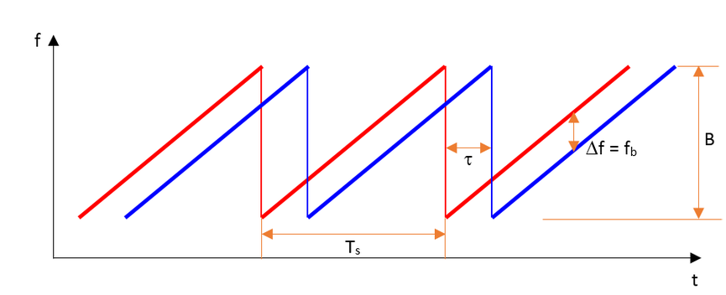

A Frequency Modulated Continous Wave (FMCW) is a signal in which the frequency increases/decreases with time. They are also referred to as upramps and downramps. The two most common waveform pattern used for FMCW radars are sawtooth and triangular. The sawtooth waveform generally uses just the upramps, whereas the triangular waveform uses both upramps and downramps.

Each chirp is defined by its slope. The slope is given by its chirp frequency bandwidth $B$ or $B_{sweep}$ (y-axis) and its chirp time $T_{s}$ (x-axis). Hence,

$Slope= \frac{B}{T_{s}}$

The range resolution requirement decides the $B$, whereas the maximum velocity capability of a radar is determined by the chirp time $T_{s}$.

One chirp sequence or segment comprises of multiple chirps. Each chirp is sampled multiple times to give multiple range measurements and radar transmits in order to measure doppler velocity accurately.

### FMCW Hardware and Antenna

**FMCW Hardware Overview**

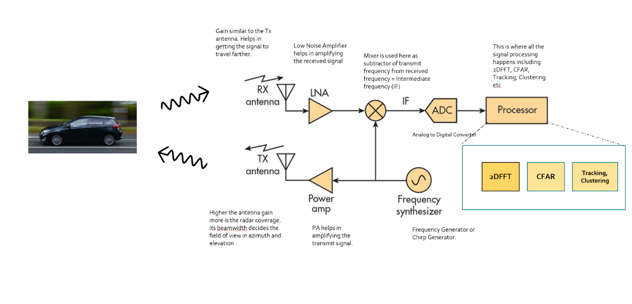

*Frequency Synthesizer*: The frequency synthesizer is the component that generates the frequency to bring the chirp frequency all the way to 77GHz in case of automotive radar.

*Power Amp*: The power amp amplifies the signal so the signal can reach long distance. Since the signal attenuates as it radiates, it needs higher power (amplitude) to reach targets at greater distances.

*Antenna*: The antenna converts the electrical energy into electromagnetic waves which radiate through the air, hit the target, and get reflected back toward the radar receiver antenna. The Antenna also increases the strength of the signal by focusing the energy in the desired direction. Additionally, the antenna pattern determines the field of view for the radar.

*Mixer*: In FMCW radar, the mixer multiplies the return signal with the sweeping signal generated by the frequency synthesizer. The operation works as frequency subtraction to give the frequency delta - also known as frequency shift or Intermediate frequency (IF). IF = Synthesizer Frequency - Return Signal Frequency.

*Processor*: The processor is the processing unit where all the Digital Signal processing, Detection, Tracking, Clustering, and other algorithms take place. This unit could be a microcontroller or even an FPGA.

**Antenna Details**

As defined in the FMCW Hardware definitions, the antenna is a transducer that converts the electrical energy into electromagnetic waves. In the case of radar, these waves travel through the air and hit the target. Depending on the surface type and shape of the target, the waves get partially reflected back in the direction of the radar. The receiver antenna at the radar amplifies the received signal further and sends it to the receiver chain for further processing.

**The Antenna Pattern**

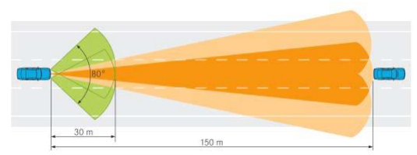

The *antenna pattern* is the geometric pattern of the strengths of the relative field emitted by the antenna. The *beamwidth* of the antenna determines the field of view for the radar sensor. If the requirement for the radar is to just sense the targets in its own lane then the beamwidth needs to be small enough to cover the complete lane up to desired range. If the beamwidth is wider than the lane width, it will sense the targets in the other lanes as well.

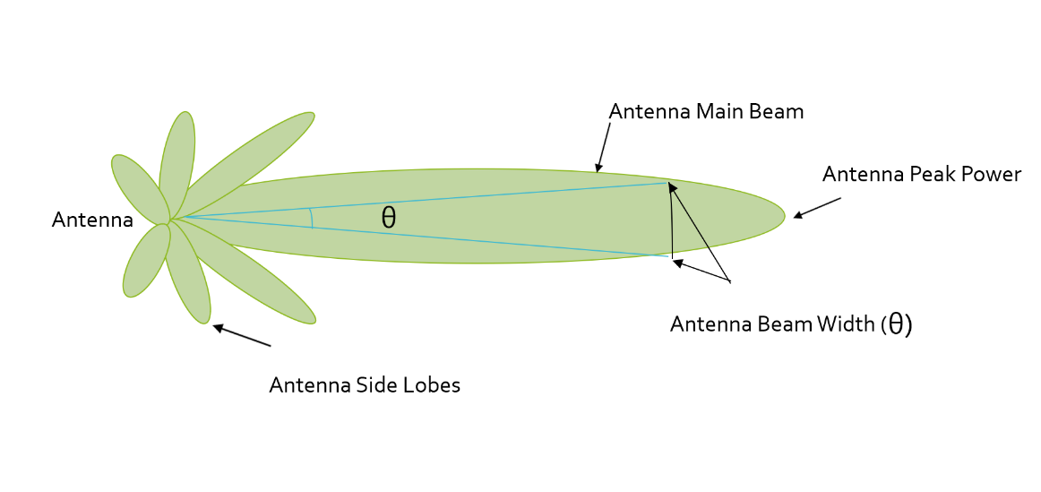

Antenna radiation not only comprises of the main beam but the sidelobes as well. Antenna sidelobes are critical because they can generate false alarms and pick interference from undesired direction. As seen in the pattern, the sidelobes of the antenna point in different directions and can sense targets that are not in the main beam. To avoid sidelobe detections it is critical to suppress the sidelobe levels to more than 30dB from the peak of the main beam.

**Antenna Types**

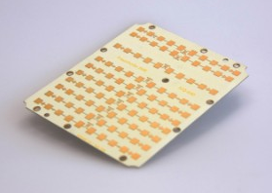

There are many types of antenna (dipole, patch, horn) that can be used at 77GHz, but the most commonly used antenna type in automotive radar is the patch antenna . The low cost, easy fabrication, and low profile of Patch Array Antennas makes them an ideal choice for automotive radar applications.

### Radar Cross Section

**Radar Cross Section Overview**

The size and ability of a target to reflect radar energy is defined by a single term, σ, known as the radar cross-section, which has units of $m^{2}.$ This unit shows that the radar cross section is an area. The target radar cross sectional area depends on:

* The target’s physical geometry and exterior features:  
  Smooth edges or surface would scatter the waves in all directions, hence lower RCS. Whereas, sharp corners will focus the return signal back in the direction of the source leading to higher RCS. (Image below for different target geometries)
* The direction of the illuminating radar
* The radar transmitter’s frequency
* The material used in the cars, trucks, bicycles, and even in some cases, the clothing material for pedestrians.

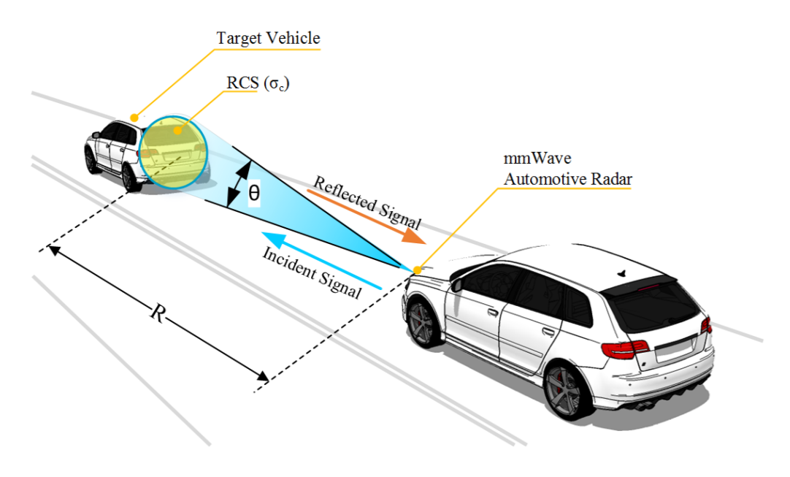

If absolutely all of the incident radar energy on the target were reflected equally in all directions, then the radar cross section would be equal to the target's cross-sectional area as seen by the transmitter. In practice, some energy is absorbed and the reflected energy is not distributed equally in all directions. Therefore, the radar cross-section is quite difficult to estimate and is normally determined by measurement.

Returns from different target geometries:

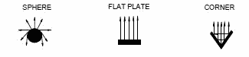

**RCS Units**

This RCS can also be defined using a logarithmic value (dB), since it increases the return signal strength. The formula for converting from RCS to dB is given by:

${RCS}_{dB}=10*\log\left({RCS}_{m^{2}}\right)$

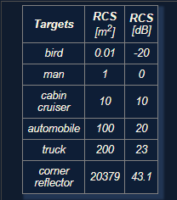

### Radar Range Equation

**Range Equation Overview**

Using the Radar Range equation we can design the radar transmitter, receiver, and antenna to have the desired power, gain and noise performance to meet the range requirements.

A long range radar designed to cover 300m range and detect a target with smaller cross section would need higher transmit power and more antenna gain as compared to a short range radar designed to cover just 50m for similar target. A target with higher cross section can be detected at a longer range as compared to a target with smaller cross section.

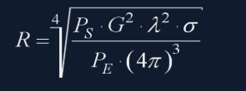

* $R$- Maximum Range a radar can detect targets.
* $P_{s}$- Transmitted Power from Radar ($dBm$)
* $G$- Gain of the Transmit/Receive Antenna ($dBi$)
* $λ$- Wavelength of the signal ($m$)
* $σ$- radar cross section ($m^{2})$
* $P_{E}$- Minimum received power radar can detect

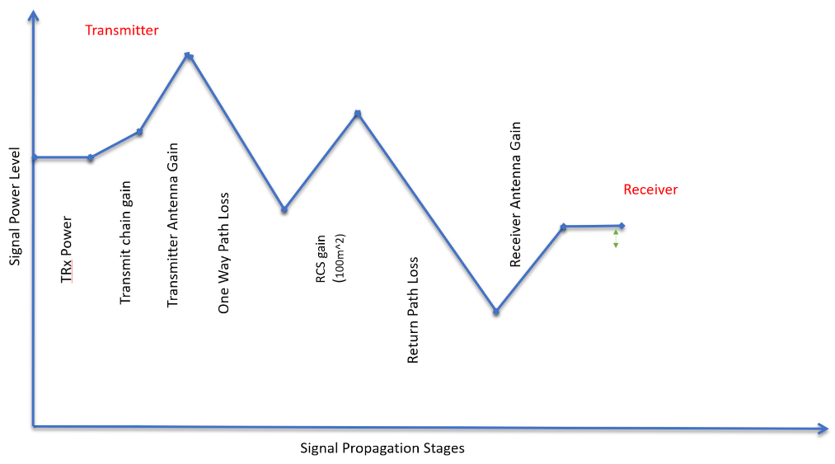

The image above shows the variation in the signal strength level as it travels through transmitter, over the air and at the receiver

The image above shows the variation in the signal strength level :

* The transmitter power
* Power Amplifiers further increase the signal strength - Transmit chain gain
* Signal is further amplified using an antenna
* One Way Path Loss represents the loss in the signal strength as it travels towards the target
* On getting reflected from the target the signal gets amplified based on the RCS of the target
* After RCS gain the signal travel back towards the radar and has similar loss in strength as going forward
* The receiver antenna amplifies the return signal before sending it to the processing unit

**Radar Detection**

Below is an illustration showing the output of a radar's range detection. The peaks correspond to the strength of the return signal from targets and the frequency relates to the range. Relationship between frequency and range will be discussed in next lesson.

A radar cannot detect a signal that is below the noise level. The noise level is determined by the thermal noise generated by the receiver. To successfully detect a target, the return signal strength needs to be larger than the noise level. This is defined by a property called signal to noise ratio, or SNR.

SNR is a quantitative measure of a signal strength as compared to the level of noise. If the SNR is too low it becomes difficult for a radar to distinguish the signal from noise. Hence, higher SNR is desirable for successful detection of the target. Generally, a 7-13 dB SNR ensures successful detection in a road scenario.

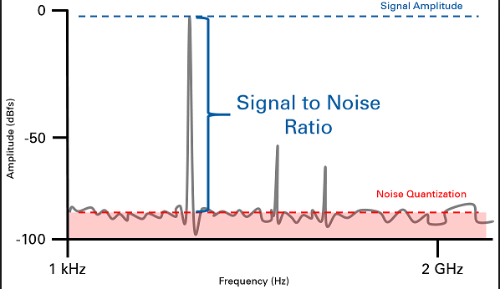

The image above shows the logarithmic value of SNR = power level (in dBm) - noise level (dBm). The plot shows the output of Range FFT. In general, the higher the SNR value, the greater are the chances of successful Radar detection.

### Placeholder

## Range-Doppler Estimation

### Range, Velocity and Angle Resolution

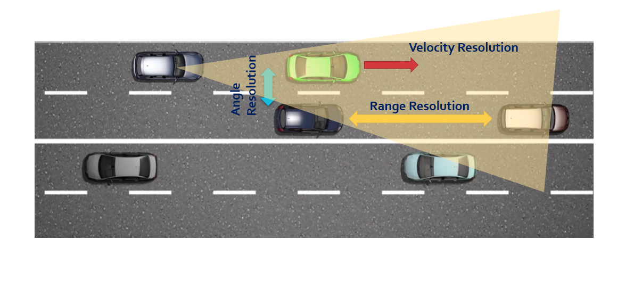

**Range Resolution**: It is the capability of the radar to distinguish between two targets that are very close to each other in range. If a radar has range resolution of 4 meters then it cannot separate on range basis a pedestrian standing 1 m away from the car.

The range resolution is solely dependent on the bandwidth of the chirp $B_{sweep}$:

$d_{res}= \frac{c}{2B_{sweep}}$

**Velocity Resolution**: If two targets have the same range they can still be resolved if they are traveling at different velocities. The velocity resolution is dependent on the number of chirps. As discussed for our case we selected to send 128 chirps. A higher number of chirps increases the velocity resolution, but it also takes longer to process the signal.

**Angle Resolution**: Radar is capable of separating two targets spatially. If two targets are at similar range travelling at same velocities, then they can still be resolved based on their angle in radar coordinate system. Angle resolution depends on different parameters depending on the angle estimation technique used.

### Range Estimation

**Range Estimation Overview**

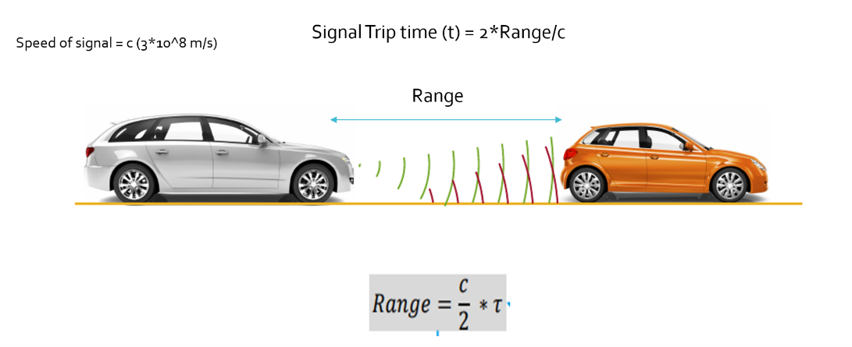

Radar determines the range of the target by measuring the trip time of the electromagnetic signal it radiates. It is known that EM wave travels at a known speed (300,000,000 m/s), so to determine the range the radar needs to calculate the trip time by measuring the shift in the frequency.

**Range Estimation Equation**

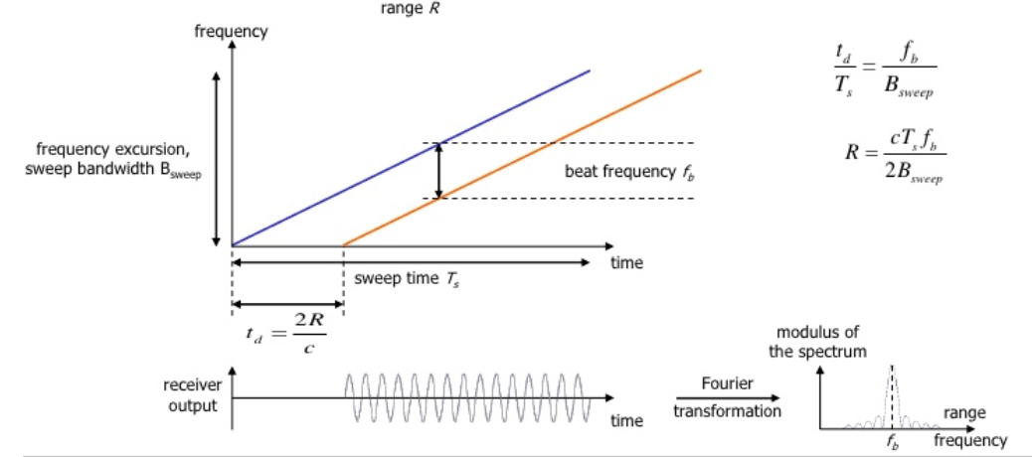

The FMCW waveform has the characteristic that the frequency varies linearly with time. If radar can determine the delta between the received frequency and hardware’s continuously ramping frequency then it can calculate the trip time and hence the range. We further divide Range estimate by 2, since the frequency delta corresponds to two way trip.

It is important to understand that if a target is stationary then a transmitted frequency and received frequency are the same. But, the ramping frequency within the hardware is continuously changing with time. So, when we take the delta (beat frequency) between the received and ramping frequency we get the trip time.

$R= \frac{cT_{s}f_{b}}{2B_{sweep}}$

Here, $f_{b}$ is the beat frequency, which is measured by the radar by subtracting the received frequency from the hardware’s ramping frequency:

$f_{b}= f_{ramping}- f_{received}$

As seen in the equation, the range calculation requires chirp time $T_{s}$ and chirp Bandwidth $B_{sweep}$. Those values are determined as we define the configuration of the radar based on its range resolution and trip time for Radar’s maximum range.

**System Level Range Calculation**

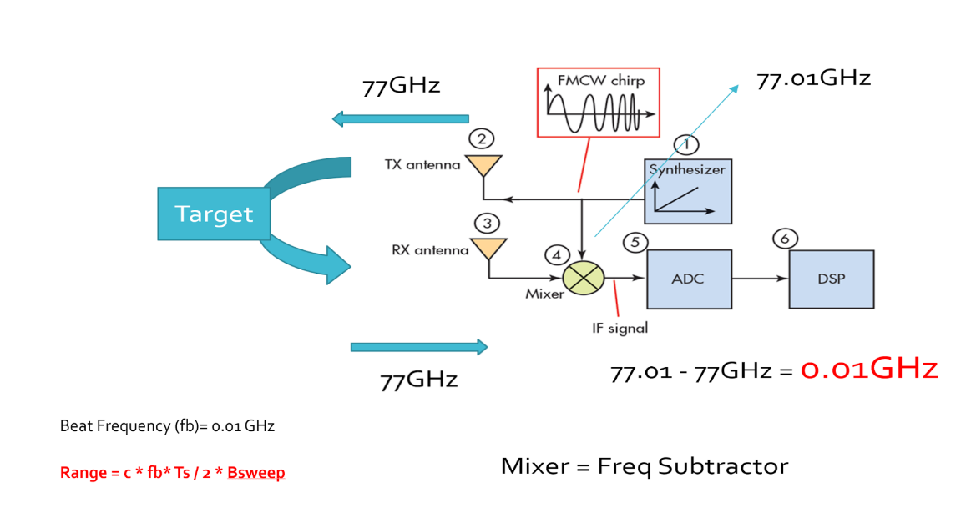

As seen in the image above, the Synthesizer generates FMCW chirp for a given $B_{sweep}$ and $T_{s}$. Let’s say the signal gets transmitted at 77GHz and it returns to the radar after hitting the target in a certain time duration. The radar receiver captures the signal, processes (subtraction) and measures the frequency delta between received signal and linearly ramping signal. This delta in frequency is called as beat frequency and it is proportional to the trip time. So based on the equation above, the radar calculates the range.

### Doppler Estimation

**Doppler Estimation Overview**

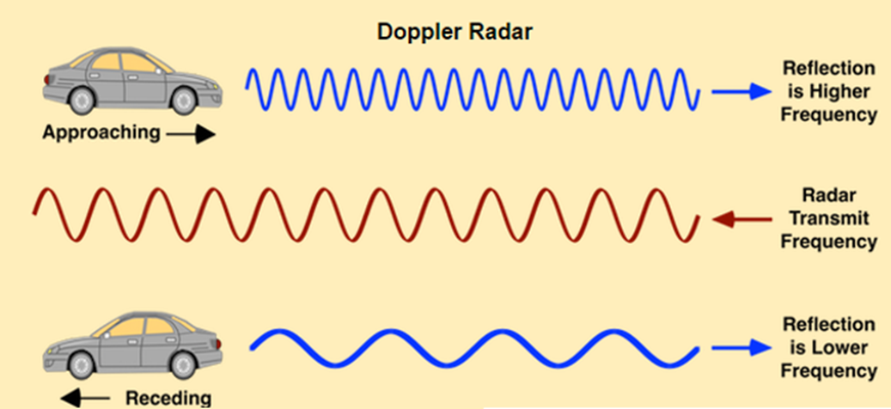

The velocity estimation for radar is based on an age old phenomenon called the doppler effect. As per doppler theory an approaching target will shift an emitted and reflected frequency higher, whereas a receding target will shift the both frequencies to be lower than the transmitted frequency.

**FMCW Doppler Measurements**

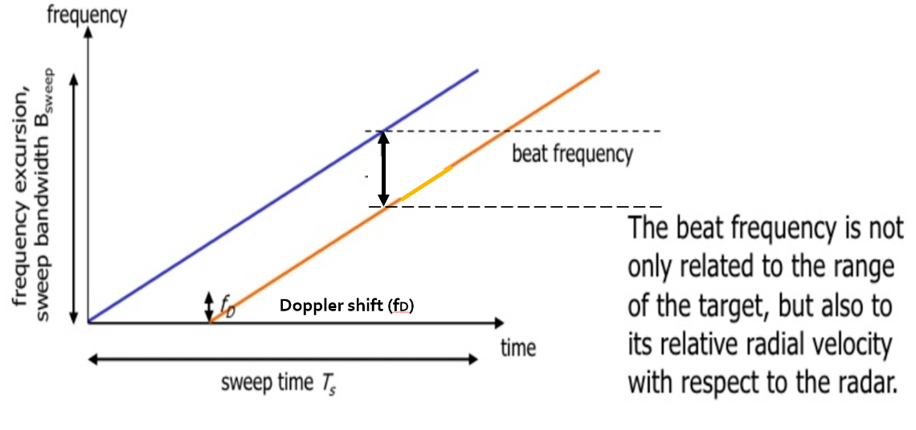

As discussed above, there will be a shift in the received signal frequency due to the doppler effect of the target’s velocity. The doppler shift is directly proportional to the velocity of the target as shown below:

$f_{D}= \frac{2v_{r}}{λ}$

$f_{D}$: shift in the transmitted frequency due to the doppler

$v_{r}$: relative velocity of the target

$λ$: wavelength of the signal

By measuring the shift in the frequency due to doppler, radar can determine the velocity. The receding target will have a negative velocity due to the frequency dropping lower, whereas the approaching target will have positive velocity as the frequency shifts higher.

The beat frequency comprises of both frequency components: $f_{r}$ (frequency delta due to range) and $f_{d}$ (frequency shift due to velocity). Although, in the case of automotive radar the $f_{d}$ is very small in comparison to the $f_{r}$. Hence, the doppler velocity is calculated by measuring the rate of change of phase across multiple chirps.

The following equation shows the relationship between the rate of change of the phase $φ$, and the frequency:

$$\frac{dφ}{dt}= frequency$$

**Doppler Phase Shift**

Keeping that in consideration, we calculate the doppler frequency by measuring the rate of change of phase. The phase change occurs due to small displacement of a moving target for every chirp duration. Since, each chirp duration is generally in microseconds, it results in small displacement in mm (millimeters). These small displacements for every chirp leads to change in phase. Using this rate of change of phase we can determine the doppler frequency.

If the path between a target and the radar is changed by an amount Δx, the phase of the wave received by radar is shifted by

$Δφ= \frac{Δx}{λ} \left(λ=2π or 360˚\right)$ $$Δφ=f* \frac{Δx}{c} (λ= f/c)$$

where λ and f are, respectively, the wavelength and frequency of the signal and c is the speed of propagation. The resulting change in observed frequency is

$Δf= \frac{Δφ}{Δt}$

where $Δt$ is the time taken for the observation of the phase change.

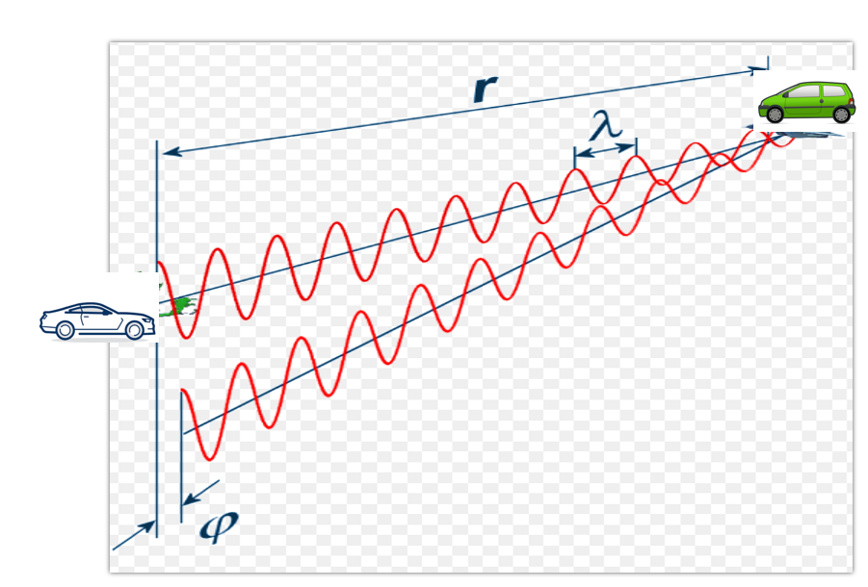

### Fast Fourier Transform

**FFT Overview**

So far we discussed the theory of range and doppler estimation along with the equations to calculate them. But, for a radar to efficiently process these measurements digitally, the signal needs to be converted from analog to digital domain and further from time domain to frequency domain.

ADC (Analog Digital Converter) converts the analog signal into digital. But, post ADC the Fast Fourier Transform is used to convert the signal from time domain to frequency domain. Conversion to frequency domain is important to do the spectral analysis of the signal and determine the shifts in frequency due to range and doppler.

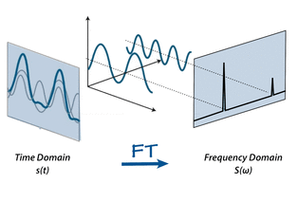

The traveling signal is in time domain. Time domain signal comprises of multiple frequency components as shown in the image above. In order to separate out all frequency components the FFT technique is used. FFT gives the frequency response of the return signal with each peak in frequency spectrum representing the detected target’s characteristics.

**FFT and FMCW**

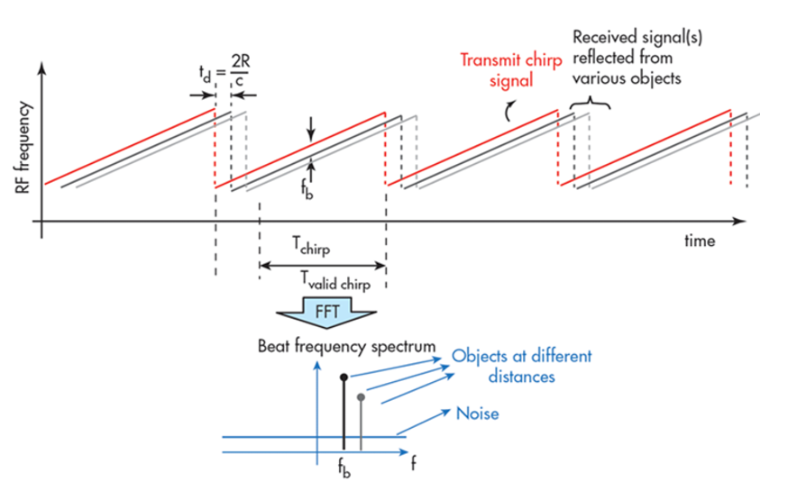

As seen in the image below, the Range FFTs are run for every sample on each chirp. Since each chirp is sampled N times, it will generate a range FFT block of N * (Number of chirps). These FFT blocks are also called FFT bins.

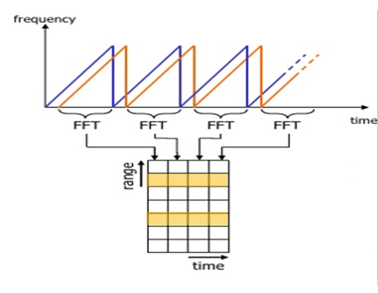

Range FFT

Each chirp is sampled N times, and for each sample it produces a range bin. The process is repeated for every single chirp. Hence creating a FFT block of N*(Number of chirps).

Each bin in every column of block represents increasing range value, so that the end of last bin represents the maximum range of a radar.

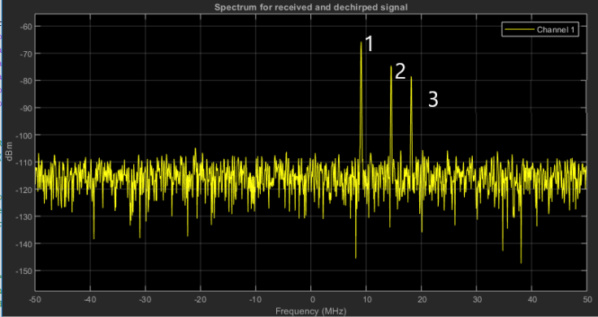

Output of Range FFT in MATLAB. X-axis = Beat Frequency, Y-axis = Signal power in dBm

Above is the output of the 1st stage FFT (i.e Range FFT). The three peaks in the frequency domain corresponds to the beat frequencies of three different cars located at 150, 240 and 300 m range from the ego vehicle.

### The 2D FFT

Once the range bins are determined by running range FFT across all the chirps, a second FFT is implemented along the second dimension to determine the doppler frequency shift. As discussed, the doppler is estimated by processing the rate of change of phase across multiple chirps. Hence, the doppler FFT is implemented after all the chirps in the segment are sent and range FFTs are run on them.

The output of the first FFT gives the beat frequency, amplitude, and phase for each target. This phase varies as we move from one chirp to another (one bin to another on each row) due to the target’s small displacements. Once the second FFT is implemented it determines the rate of change of phase, which is nothing but the doppler frequency shift.

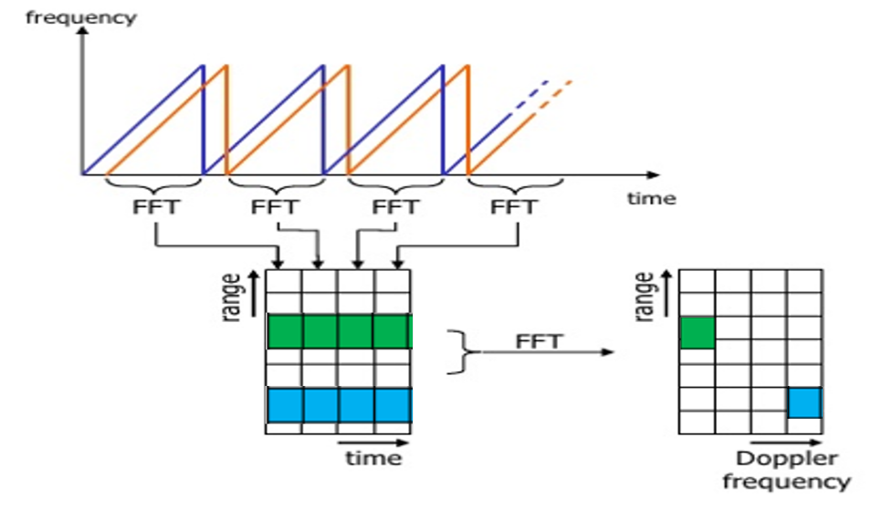

After running 2nd FFT across the rows of FFT block we get the doppler FFT. The complete implementation is called 2D FFT.

After 2D FFT each bin in every column of block represents increasing range value and each bin in the row corresponds to a velocity value. The output of Range Doppler response represents an image with Range on one axis and Doppler on the other. This image is called as Range Doppler Map (RDM). These maps are often used as user interface to understand the perception of the targets.

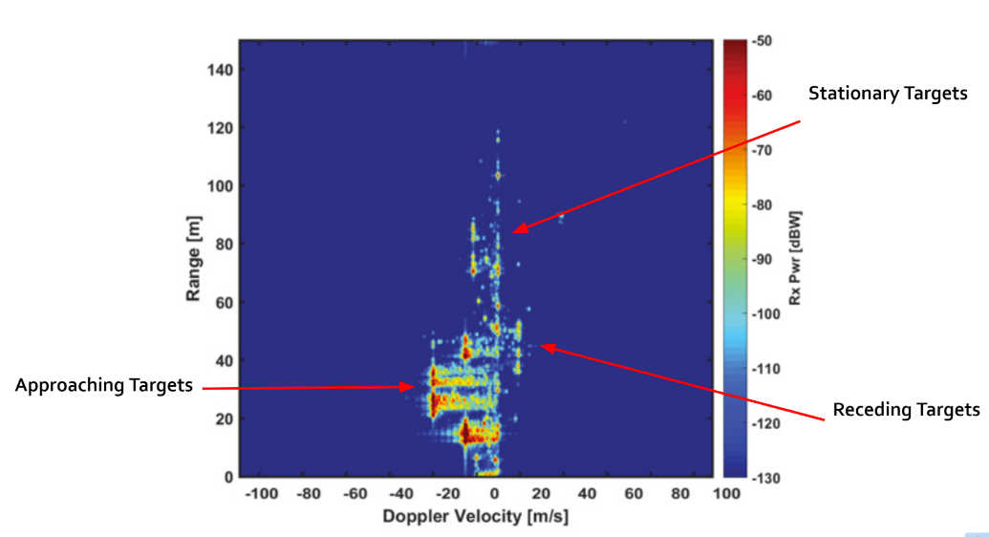

### Placeholder

* + 1. ff

## Clutter, CFAR, AoA

### Clutter

Radar not only receives the reflected signals from the objects of interest, but also from the environment and unwanted objects. The backscatter from these unwanted sources is called clutter.

These unwanted signals are generally produced by reflections from the ground, sea, buildings, trees, rain, fog etc. The magnitude of the clutter signal depends upon:

* The nature of the surface - ground, water, snow (e.g deserts have low reflectivity, whereas the frozen snow has high reflectivity)
* Smoothness of the surface
* Grazing angle - Angle the radar beam makes with the surface
* Radar Frequency

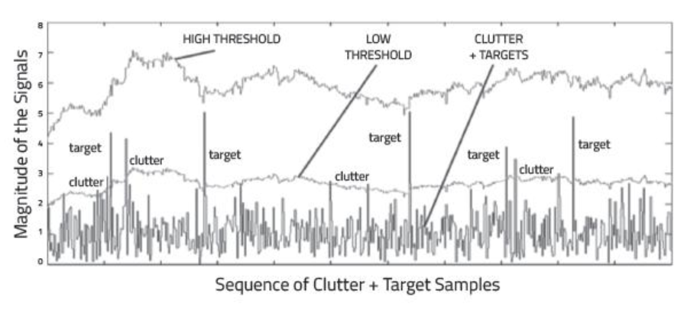

Return Signal from multiple targets along with some from the clutter

**Clutter Thresholding**

It is important to filter out clutter for successful detection of targets. This is critical in a driving scenario to avoid the car from suddenly braking in the absence of valid targets. This sudden braking happens when the radar detects reflections that are generated from the clutter.

One technique to remove clutter is to remove the signals having 0 doppler velocity. Since, the clutter in the driving scenario are often created by the stationary targets, the 0 doppler filtering can help get rid of them.

The downside of 0 doppler filtering is that the radar would not be able to detect the stationary targets in its path. This would lead to detection failures.

Another technique is to use fixed clutter thresholding. With fixed thresholding, signal below the threshold value is rejected. With this method, if the detection threshold is set too high, there will be very few false alarms, but it will also mask the valid targets. If the threshold is set too low, then it would lead to too many false alarms. In other words, the false alarm rate would be too high.

The false alarm rate is the rate of erroneous radar detections by noise or other interfering signals. It is a measure of the presence of detected radar targets when there is no valid target present.

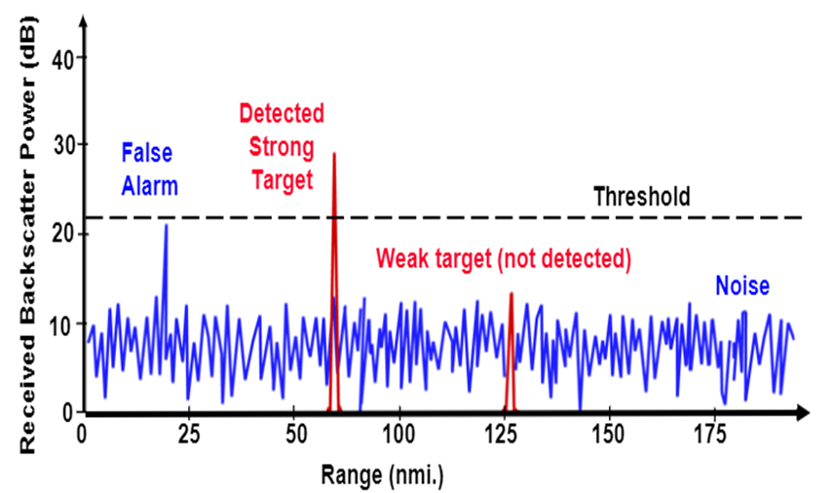

Fixed Threshold leading to False Alarms and missed detections of weak target

**Dynamic Thresholding**

Another approach to clutter thresholding is to use dynamic thresholding. Dynamic thresholding involves varying the threshold level to reduce the false alarm rate.

CFAR (Constant False Alarm Rate) is a dynamic thresholding technique. With this technique, the noise at every or group of range/doppler bins is monitored and the signal is compared to the local noise level. This comparison is used to create a threshold which holds the false alarm rate constant.

### CFAR

CFAR

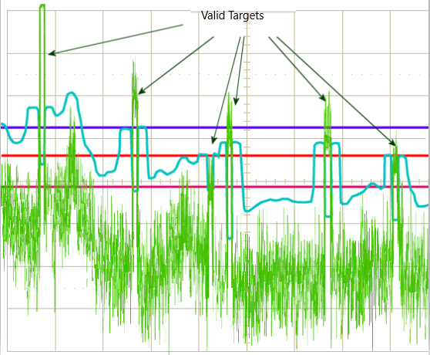

CA-CFAR and OS-CFAR

The false alarm issue can be resolved by implementing the constant false alarm rate. CFAR varies the detection threshold based on the vehicle surroundings. The CFAR technique estimates the level of interference in radar range and doppler cells “Training Cells” on either or both the side of the “Cell Under Test”. The estimate is then used to decide if the target is in the Cell Under Test (CUT).

The process loops across all the range cells and decides the presence of target based on the noise estimate. The basis of the process is that when noise is present, the cells around the cell of interest will contain a good estimate of the noise, i.e. it assumes that the noise or interference is spatially or temporarily homogeneous. Theoretically it will produce a constant false alarm rate, which is independent of the noise or clutter level.

There are multiple categories of CFAR:

* Cell Averaging CFAR (CA-CFAR)
* Ordered Statistics CFAR (OS CFAR)
* Maximum Minimum Statistic (MAMIS CFAR)
* And, multiple variants of CA-CFAR.

Here, we will be covering the basic CA-CFAR.

### CA-CFAR

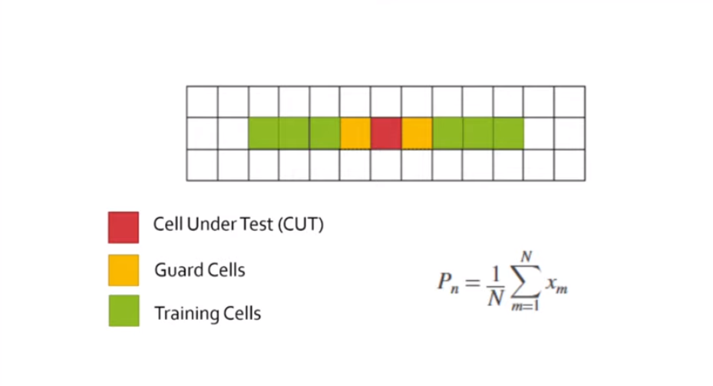

CA-CFAR Training Cells : 3 Guard Cell : 1

CA-CFAR is the most commonly used CFAR detection technique. As seen in the previous lesson, the FFT blocks are generated on implementing range and doppler FFTs across the number of chirps. The CFAR process includes the sliding of a window across the cells in FFT blocks. Each window consists of the following cells.

**Cell Under Test** : The cell that is tested to detect the presence of the target by comparing the signal level against the noise estimate (threshold).

**Training Cells** : The level of noise is measured over the Training Cells. The Training Cells can be divided into two regions, the cells lagging the CUT, called lagging Training Cells and the cells leading the CUT, called Leading Training Cells. The noise is estimated by averaging the noise under the training cells. In some cases either leading or lagging cell average is taken, while in the other the leading and lagging cell average is combined and the higher of two is considered for noise level estimate.The number of training cells should be decided based on the environment. If a dense traffic scenario then the fewer training cells should be used, as closely spaced targets can impact the noise estimate.

**Guard Cells** : The cells just next to CUT are assigned as Guard Cells. The purpose of the Guard Cells is to avoid the target signal from leaking into the training cells that could adversely affect the noise estimate. The number of guard cells should be decided based on the leakage of the target signal out of the cell under test. If target reflections are strong they often get into surrounding bins.

**Threshold Factor (Offset)** : Use an offset value to scale the noise threshold. If the signal strength is defined in logarithmic form then add this offset value to the average noise estimate, else multiply it.

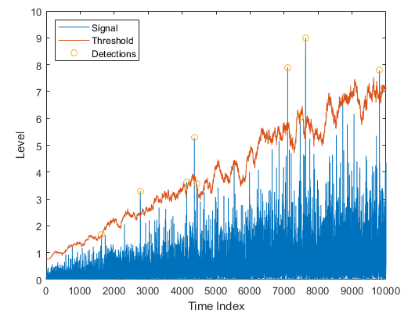

### CFAR 2D

The 2D CFAR is similar to 1D CFAR, but is implemented in both dimensions of the range doppler block. The 2D CA-CFAR implementation involves the training cells occupying the cells surrounding the cell under test with a guard grid in between to prevent the impact of a target signal on the noise estimate.

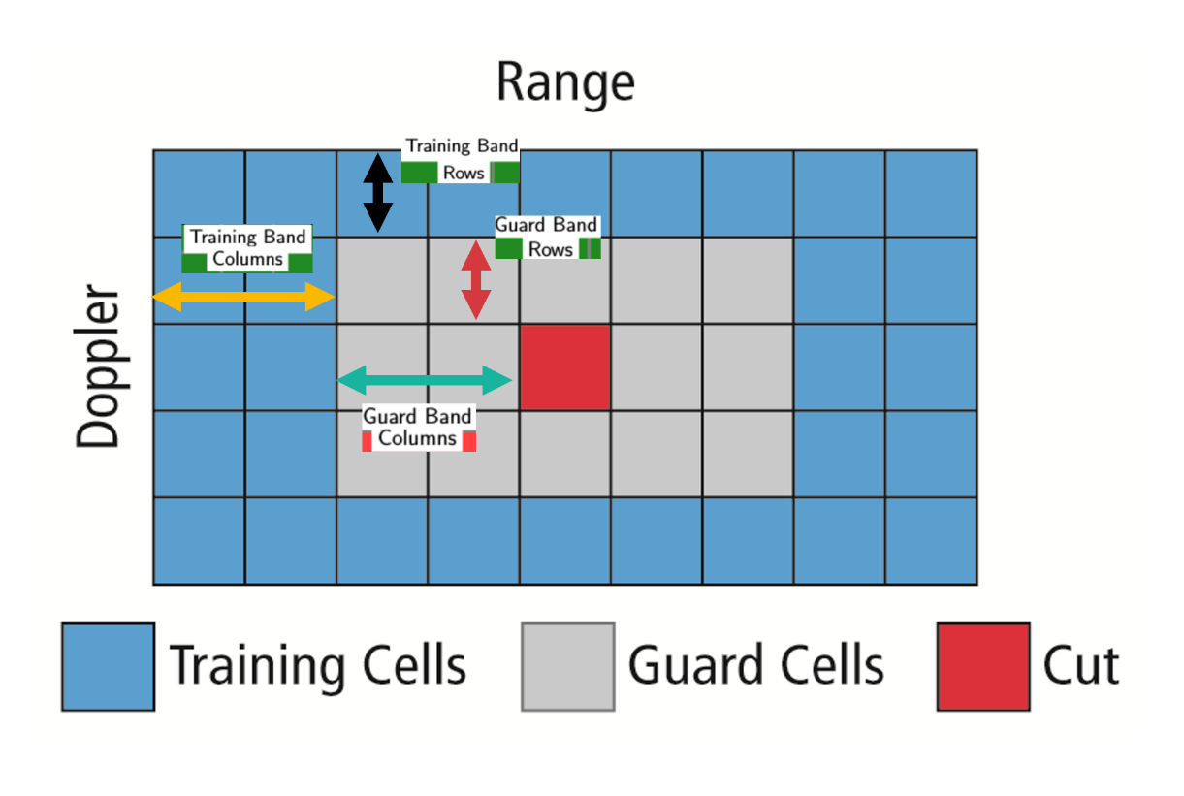

### Angle of Arrival

A phased array antenna is an antenna array that steers the beam electronically in the desired direction. The array steers the beam if each antenna element in an array is excited by the signal with certain phase values. This phenomenon is referred to as beam scanning.

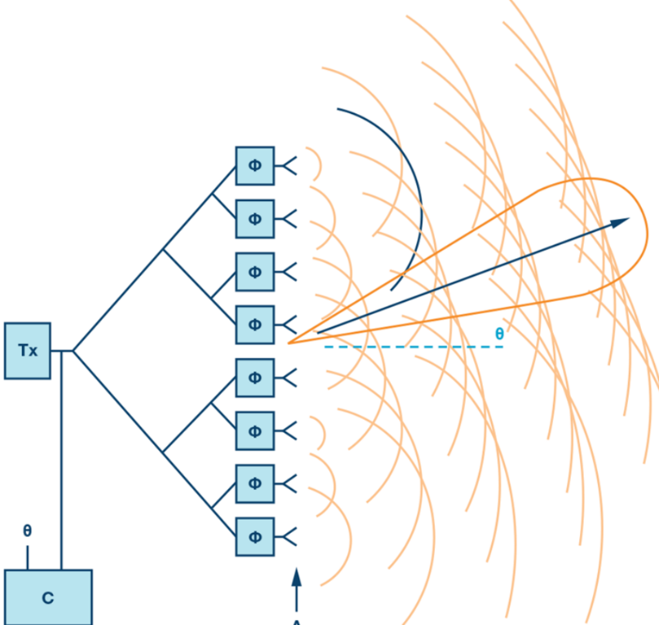

Beam Steering Design.

Here the Φ represents the phase shifters. Phase shifters are the electronic components that changes the phase to make the beam steer in a desired direction.

For antenna beam to steer in a desired direction, the phase shifters are programmed to have constant phase increments. If an antenna comprises of six radiating elements and the phase delta required to steer a beam in a given direction is 15 degrees, then the following would be the phase value on each element [0,15,30,45,60,75] degrees. The increment phase shift along with the spacing between antenna elements (d) determines the steering angle of an antenna using the following equation

$Φ=360*d*sin⁡(Θ)/λ$

* $Φ$ = incremental phase shift
* $d$ = spacing between antenna elements
* $Θ$ = steering direction from normal of the antenna surface
* $λ$ = wavelength of the signal

As the radar scan the surroundings by steering the beam at the programmed angles, it can sense the angle of the return signal. This helps Radar create a spatial perception of the environment.

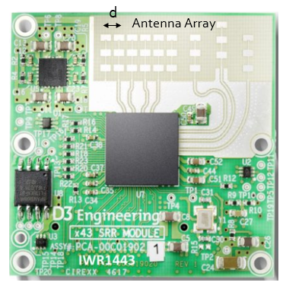

As the radar scans the surroundings by steering the beam at the programmed angles, it measures the SNR of reflected signals from targets located at different angles spatially. This helps in creating an angle of arrival vs SNR grid for radar’s spatial perception.

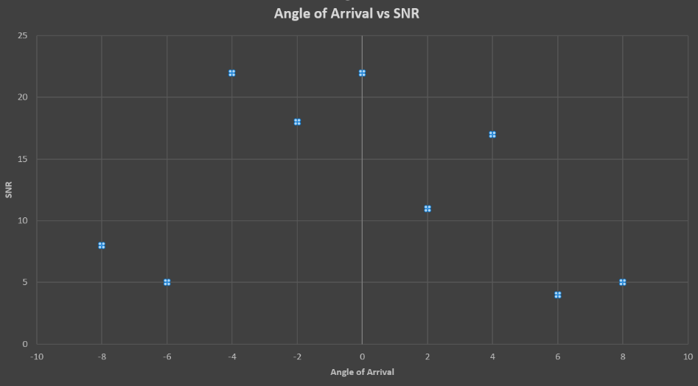

* + 1. Placeholder

## Clustering and Tracking

### Clustering

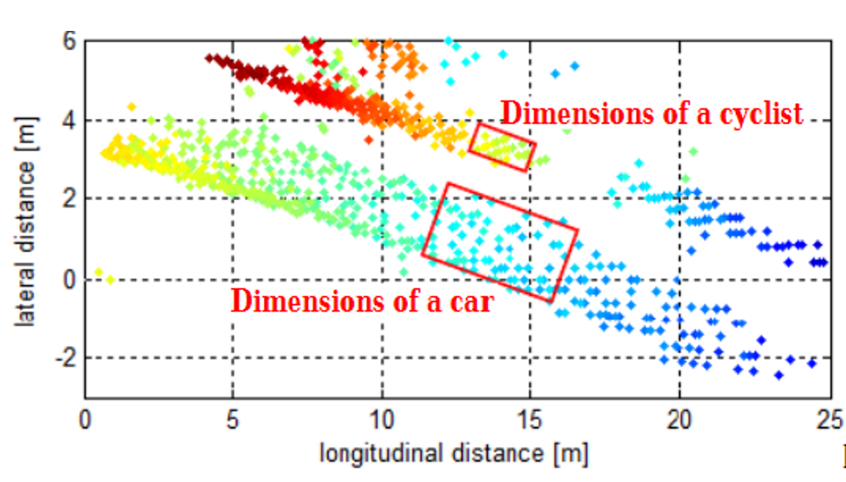

Clustering of a car and bicycle

For enhanced perception in autonomous driving, there is a need to track multiple targets separately. The object tracking is computationally expensive and tracking multiple targets simultaneously requires lots of processing power and memory.

Due to the advancements in radar technology and increasing sensing resolutions, a radar can generate detections from plentitude of scattering points on the target. If a tracker is assigned to every detection from the same target, then it can overburden the processing unit. Hence, it is important to cluster the detections from every target and assign a single track for each.

Here we will discuss the basic clustering algorithm based on the euclidean distance. The algorithm here groups the detection points based on their proximity measured by the euclidean distance between those points.

All the detection points that are within the size of the target are considered as one cluster, merged into a centroid position. Each cluster is now assigned a new range and velocity, which is the mean of measured range and velocity of all the detection points that form the cluster.

This allows valid tracking for each target.

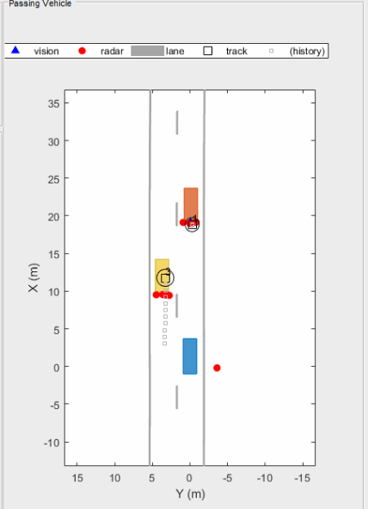

Above is an illustration of the clustering scenario. In the image the blue car is an ego vehicle (vehicle with sensor) and the detections are generated from the orange and yellow vehicles. Using clustering algorithm all the detections associated with the single target are merged into one point. This helps in the detection and assigning the tracks to a target.

### Kalman Tracking

**MATLAB Sensor Fusion**

Sensor fusion and control algorithms for automated driving systems require rigorous testing. Vehicle-based testing is not only time consuming to set up, but also difficult to reproduce. Automated Driving System Toolbox provides functionality to define road networks, actors, vehicles, and traffic scenarios, as well as statistical models for simulating synthetic radar and camera sensor detection. This example shows how to generate a scenario, simulate sensor detections, and use sensor fusion to track simulated vehicles. The main benefit of using scenario generation and sensor simulation over sensor recording is the ability to create rare and potentially dangerous events and test the vehicle algorithms with them.

* + 1. Placeholder

## Radar Target Generation and Detection

### Radar Target Generation and Detection

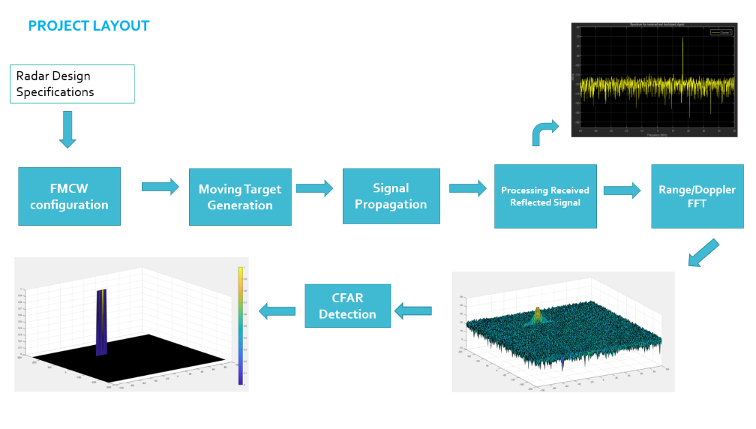

* Configure the FMCW waveform based on the system requirements.
* Define the range and velocity of target and simulate its displacement.
* For the same simulation loop process the transmit and receive signal to determine the beat signal
* Perform Range FFT on the received signal to determine the Range
* Towards the end, perform the CFAR processing on the output of 2nd FFT to display the target.

**Radar System Requirements**

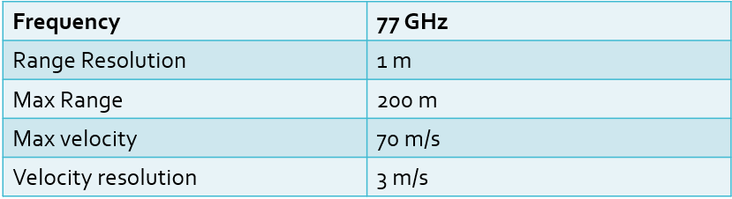

System Requirements defines the design of a Radar. The sensor fusion design for different driving scenarios requires different system configurations from a Radar. In this project, you will designing a Radar based on the given system requirements (above). Max Range and Range Resolution will be considered here for waveform design.

* The sweep bandwidth can be determined according to the range resolution and the sweep slope is calculated using both sweep bandwidth and sweep time.
$$Bandwidth\left(B_{sweep}\right)= \frac{speed of light}{2*rangeResolution}$$

* The sweep time can be computed based on the time needed for the signal to travel the unambiguous maximum range. In general, for an FMCW radar system, the sweep time should be at least 5 to 6 times the round trip time. This example uses a factor of 5.5.Giving the slope of the chirp signal

$$T_{chirp}=5.5* \frac{2R_{max}}{c}$$

Giving the slope of the chirp signal

$$Slope= \frac{Bandwidth}{T_{chirp}}$$

**Initial Range and Velocity of the Target**

You will provide the initial range and velocity of the target. Range cannot exceed the max value of 200m and velocity can be any value in the range of -70 to + 70 m/s.

**Target Generation and Detection**

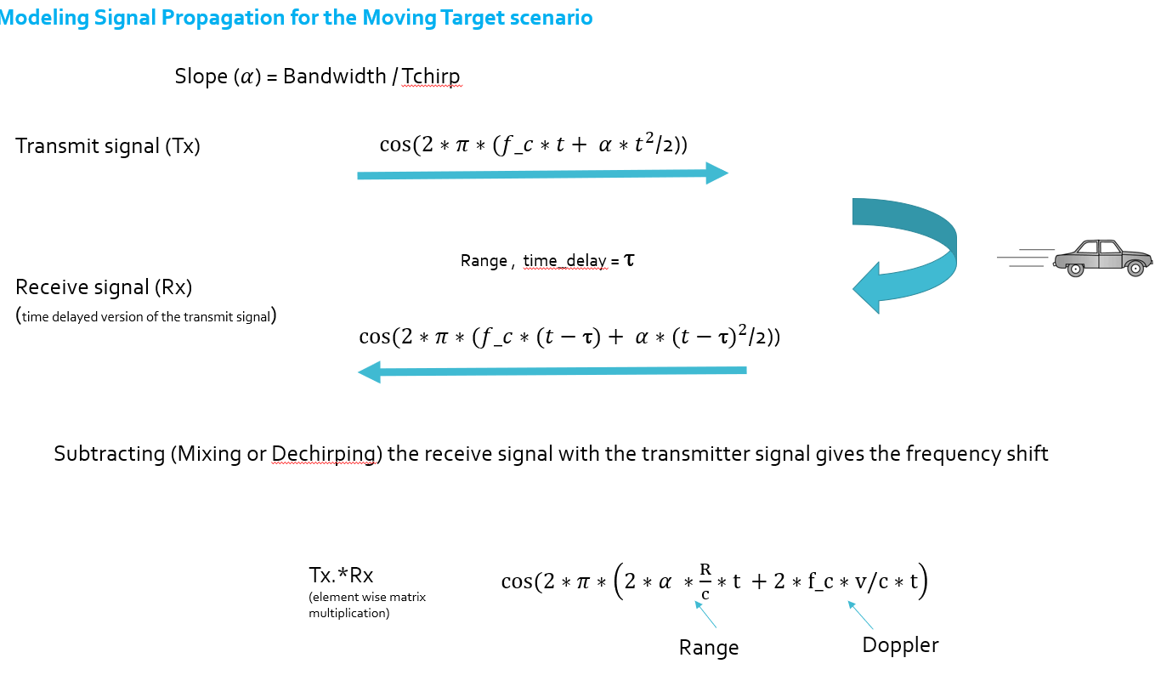

Next, you will be simulating the signal propagation and moving target scenario.

Theory : In terms of wave equation, FMCW transmit and receive signals are defined using these wave equations, where α = *Slope of the signal*. The Transmit Signal is given by:

$$T_{x}=\cos\left(2π\left(f_{c}t+ \frac{αt^{2}}{2}\right)\right)$$

The received signal is nothing but the time delayed version of the Transmit Signal. In digital signal processing the time delayed version is defined by $(t- τ)$, where $τ$ represents the delay time, which in radar processing is the trip time for the signal.

Replacing $t$ with $(t- τ)$ gives the Receive Signal:

$$R_{x}= \cos\left(2π\left(f_{c}(t-τ)+ \frac{α{(t- τ)}^{2}}{2}\right)\right)$$

On mixing these two signals, we get the beat signal, which holds the values for both range as well as doppler. By implementing the 2D FFT on this beat signal, we can extract both Range and Doppler information.

The beat signal can be calculated by multiplying the Transmit signal with Receive signal. This process in turn works as frequency subtraction. It is implemented by element by element multiplication of transmit and receive signal matrices.

$$Mixed or Beat Signal=\left(T_{x}.*R_{x}\right)$$

$$T_{x}.*R_{x}= \cos\left(2π\left(\frac{2αR}{c}t+ \frac{2f_{c}v}{c}t\right)\right)$$

**FFT Operation**

* Implement the 1D FFT on the Mixed Signal
* Reshape the vector into Nr*Nd array.
* Run the FFT on the beat signal along the range bins dimension (Nr)
* Normalize the FFT output.
* Take the absolute value of that output.
* Keep one half of the signal
* Plot the output
* There should be a peak at the initial position of the target

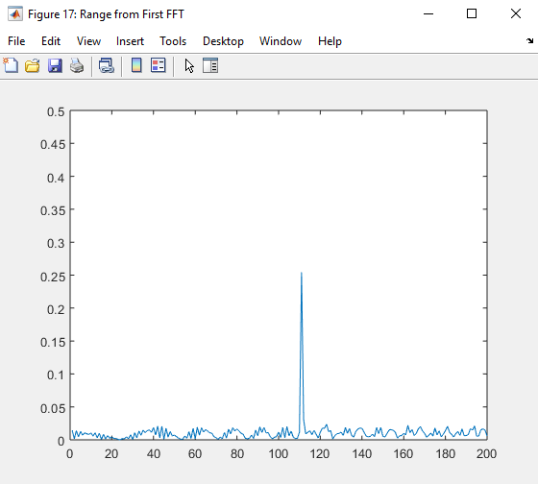

The 1st FFT output for the target located at 110 meters

The 2nd FFT is already implemented in the code. It will generate a Range Doppler Map as seen in the image below and it will be given by variable ‘RDM’. Next task is to implement the CFAR on this Range Doppler Map.

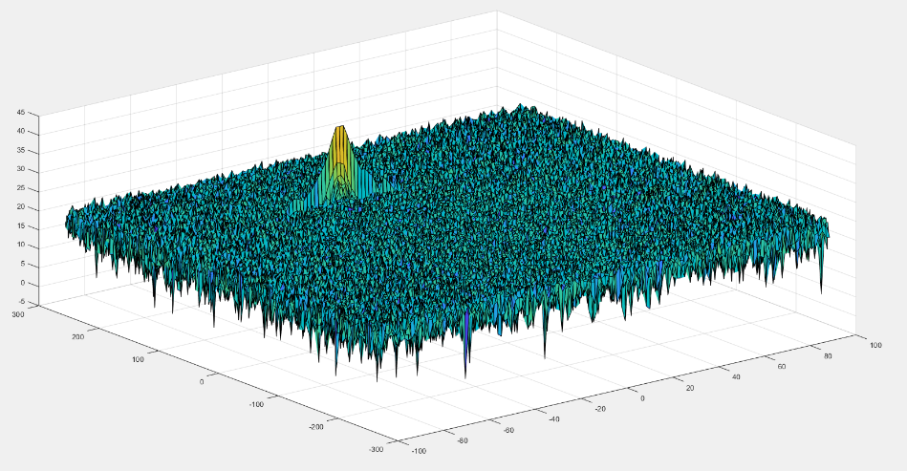

2D FFT output - Range Doppler Map

**2D CFAR**

* Determine the number of Training cells for each dimension. Similarly, pick the number of guard cells.
* Slide the cell under test across the complete matrix. Make sure the CUT has margin for Training and Guard cells from the edges.
* For every iteration sum the signal level within all the training cells. To sum convert the value from logarithmic to linear using db2pow function.
* Average the summed values for all of the training cells used. After averaging convert it back to logarithmic using pow2db.
* Further add the offset to it to determine the threshold.
* Next, compare the signal under CUT against this threshold.
* If the CUT level > threshold assign it a value of 1, else equate it to 0.

The process above will generate a thresholded block, which is smaller than the Range Doppler Map as the CUTs cannot be located at the edges of the matrix due to the presence of Target and Guard cells. Hence, those cells will not be thresholded. To keep the map size same as it was before CFAR, equate all the non-thresholded cells to 0.

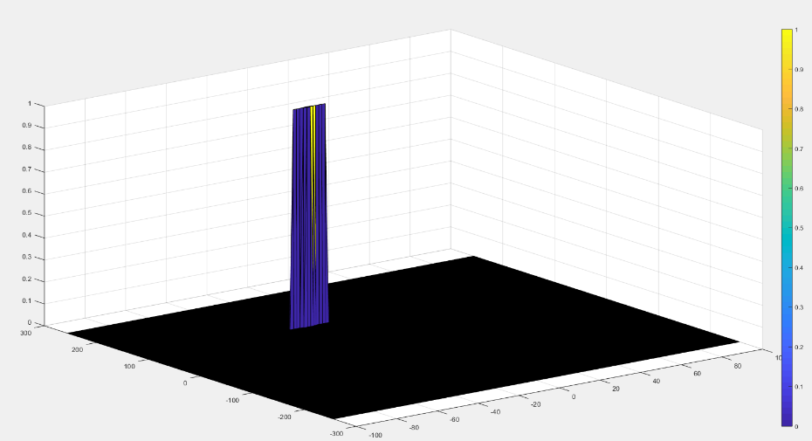

The output of the 2D CFAR process

Once you have completed this, you are done. Congratulations on doing a great job on this final project!

### 2.5.2 Placeholder

## Placeholder

# Camera

## Autonomous Vehicles and Computer Vision

### Levels of Autonomous Driving

According to CB Insights, there are 46 corporations currently working on autonomous vehicles (as of April 2019). This includes automakers such as Audi, Tesla, BMW, Volvo or GM but also new additions to the automotive space such as Alphabet / Waymo, Uber or Baidu - who hail from totally different industries.

It is expected that the autonomous vehicle market will grow from $54 billion in 2019 to $556 billion in 2026, according to Allied Market Research estimates. Such growth rates, combined with technological break-throughs of recent years, explain why things are moving so fast and why everyone is trying to get a share of this emerging market.

In addition to autonomous vehicles, there are systems which assist the driver in various driving tasks such as changing lanes, remembering speed signs or braking in time in case the preceding vehicle suddenly decelerates. Such systems are referred to as Advanced Driver Assistance Systems (ADAS) and they are the predecessor of a fully autonomous vehicle. There are some vehicles in the market, however, that imply full autonomy (such as the Tesla Autopilot), but are ‚only‘ an ADAS systems.

Before we analyze a selection of autonomous vehicle prototypes and their respective sensors, let us look at a way to define autonomy - because not all autonomous cars and driver assistance systems are created equal. The following graphic shows the „levels of autonomous driving“, which the Society of Autonomous Engineers (SAE) has defined.

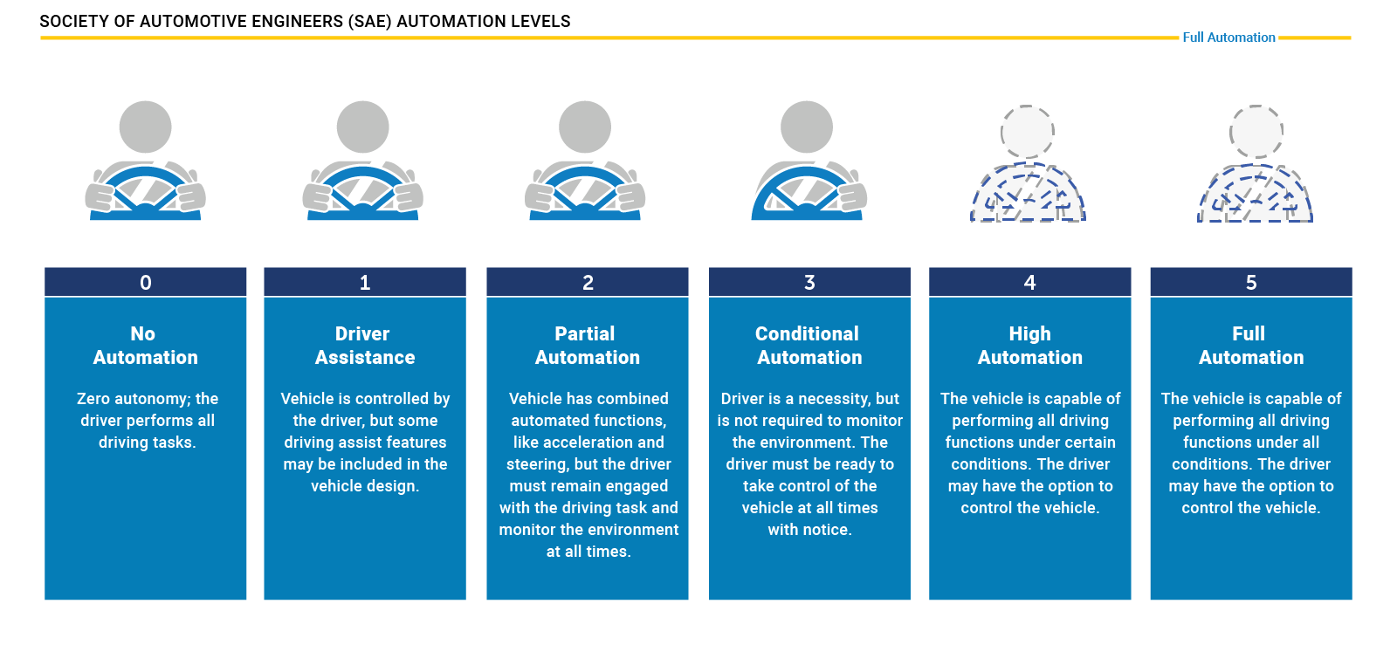

For many years, ADAS products such as forward collision warning (FCW) or adaptive cruise control (ACC) were the only systems available that provided at least some degree of automation in a selected number of driving situations (e.g. on highways, in cities at low speed).

Tesla has been one of the first companies world-wide to introduce a system into the market that promised a high degree of autonomy, the Auto Pilot. On the SAE chart however, this system is „only“ at level 2, that means the driver must remain engaged and should monitor the environment at all times.

The step to level 3 is a large one as the driver is no longer required to monitor the environment, even though he must be able to take back control at all times. From a legal viewpoint this means that the responsibility for the driving task is with the car and thus with the manufacturer. This is why we do not see a large number of commercially available vehicles with level 3 systems on board yet. Several manufacturers have announced such systems but at the time of writing (May 2019), we do not find them in the market. The reason for this is three-fold:

* Such systems must be build reliable enough to minimize the number of faulty decisions. Engineers usually solve this problem by adding a large number of sensors to the car, which makes such systems (very) costly.
* The fear of law suits arising from accidents results in an intentionally reduced availability of systems, for example by limiting the driving speed or the scenario (e.g. only in traffic jams on highways with clearly visible lane markings at speeds below 60kph).
* The readiness of the driver to take control of the vehicle can not be guaranteed at all times. There are many situations in which this is not possible due to human reaction times and alertness levels.

Therefore, many experts believe that level 3 systems will only be a transition step to more advanced systems which are operating on levels 4 and 5. At those levels, the vehicle is capable of performing all driving tasks and the „driver“ is not required to take control. Obviously, such systems will require a strong engineering effort to guarantee driver and road user safety at all times.

### Autonomous Vehicle Sensor Sets

In the last section you have learned about the different levels of autonomous driving and about the leap it takes to move from level 2 to level 3 or even further. It should now be obvious that one key to level 4 and level 5 autonomy is a smart combination of sensors and perception algorithms to monitor the vehicle environment at all times to guarantee a proper and safe reaction to all traffic events.

To give you an idea of how this problem is approached in practice, this section contains a brief overview of some vehicles that aim at realizing level 4 or even level 5 driving. As this course is mostly about cameras and computer vision and to a small degree also about Lidar, let us focus mainly on those two sensor types. Let us now take a look at a few autonomous vehicles and their respective sensor suites.

**The Uber ATG Autonomous Vehicle**

The current version of the Uber autonomous vehicle combines a top-mounted 360° Lidar scanner with several cameras and radar sensors placed around the car circumference.

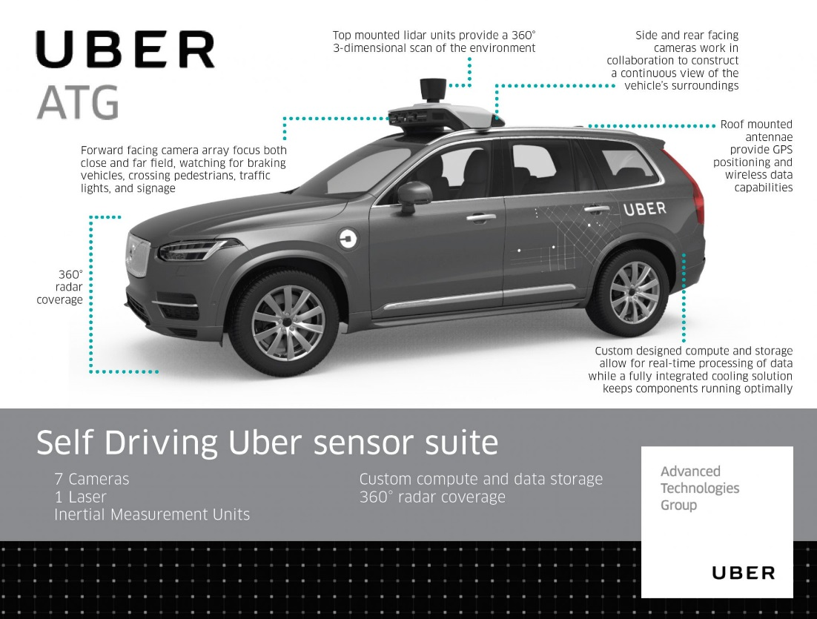

Let us take a look at those sensor classes one-by one:

* *Cameras*: Ubers fleet of modified Volvo XC90 SUVs features a range of cameras on their roofs, plus additional cameras that point to the sides and behind the car. The roof cameras are able to focus both close and far field, watch for braking vehicles, crossing pedestrians, traffic lights, and signage. The cameras feed their material to a central on-board computer, which also receives the signals of the other sensors to create a precise image of the vehicle’s surroundings. Much like human eyes, the performance of camera systems at night is strongly reduced, which makes them less reliable to locate objects with the required detection rates and positional accuracy. This is why the Uber fleet is equipped with two additional sensor types.
* *Radar*: Radar systems emit radio waves which are reflected off of (many but not all) objects. The returning waves can be analyzed with regard to their runtime (which gives distance) as well as their shifted frequency (which gives relative speed). The latter property clearly distinguished the radar from the other two sensor types as it is the only one who is able to directly measure the speed of objects. Also, radar is very robust against adverse weather conditions like heavy snow and thick fog. Used by cruise control systems for many years, radar works best when identifying larger objects with good reflective properties. When it comes to detecting smaller or „soft“ objects (humans, animals) with reduced reflective properties, the radar detection performance drops. Even though camera and radar combine well, there are situations where both sensors do not work optimally - which is why Uber chose to throw a third sensor into the mix.
* *Lidar* : Lidar works in a similar way to radar, but instead of emitting radio waves it uses infrared light. The roof-mounted sensor rotates at a high velocity and builds a detailed 3D image of its surroundings. In case of the Velodyne VLS-128, a total of 128 laser beams is used to detect obstacles up to a distance of 300 meters. During a single spin through 360 degrees, a total of up to 4 million data points per second is generated. Similar to the camera, Lidar is an optical sensor. It has the significant advantage however of "bringing its own light source“, whereas cameras are dependent on ambient light and the vehicle headlights. It has to be noted however, that Lidar performance is also reduced in adverse environmental conditions such as snow, heavy rain or fog. Coupled with low reflective properties of certain materials, a Lidar might thus fail at generating a sufficiently dense point cloud for some objects in traffic, leaving only a few 3D points with which to work. It is thus a good idea to combine Lidar with other sensors to ensure that detection performance is sufficiently high for autonomous navigation through traffic.

**Mercedes Benz Autonomous Prototype**

Currently, German car maker Mercedes Benz is developing an autonomous vehicle prototype that is equipped with cameras, Lidar and radar sensors, similar to the Uber vehicle. Mercedes uses several cameras to scan the area around the vehicle. Of special interest is a stereo setup consisting of two synchronized cameras, which is able to measure depth by finding corresponding features in both images. The picture below shows the entire host of cameras used by the system. Mercedes states that the stereo camera alone generates a total of 100 gigabytes of data for every kilometer driven.

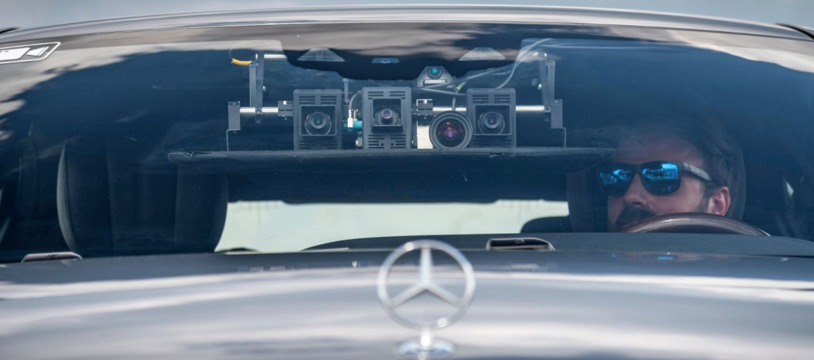

**The Tesla Autopilot**

When the Autopilot system was first sold, it basically was a combination of adaptive cruise control and lane change assist - a set of functions which had long been available with other manufacturers around the globe. The name „Autopilot“ implied however, that the car would be truly autonomous. And indeed did many Tesla owners test the system to its limits by climbing onto the back seat , reading a book or taking a nap while being driven by the system. On the SAE scale however, the Autopilot can „only“ be classified as level 2, i.e. the driver is responsible for the driving task at all times.

In October 2016, the Tesla Model S and X sensor set was significantly upgraded and the capabilities of the Autopilot were extended by regular airborne software updates.

The image shows the interior of a Tesla with the camera views superimposed on the right side. The image shows left and right rear-facing cameras as well as a forward-facing camera for medium-range perception.

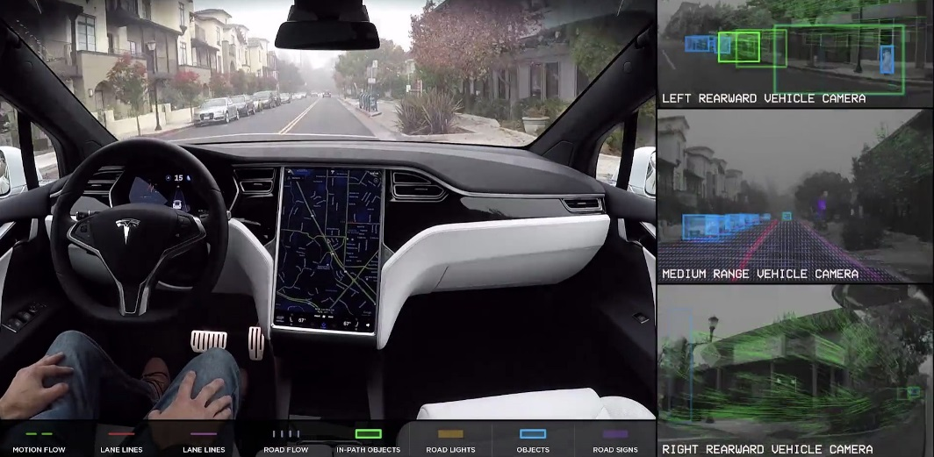

As can be seen in the overview, the system combines several camera sensors with partially overlapping fields of view with a forward-facing radar sensor.

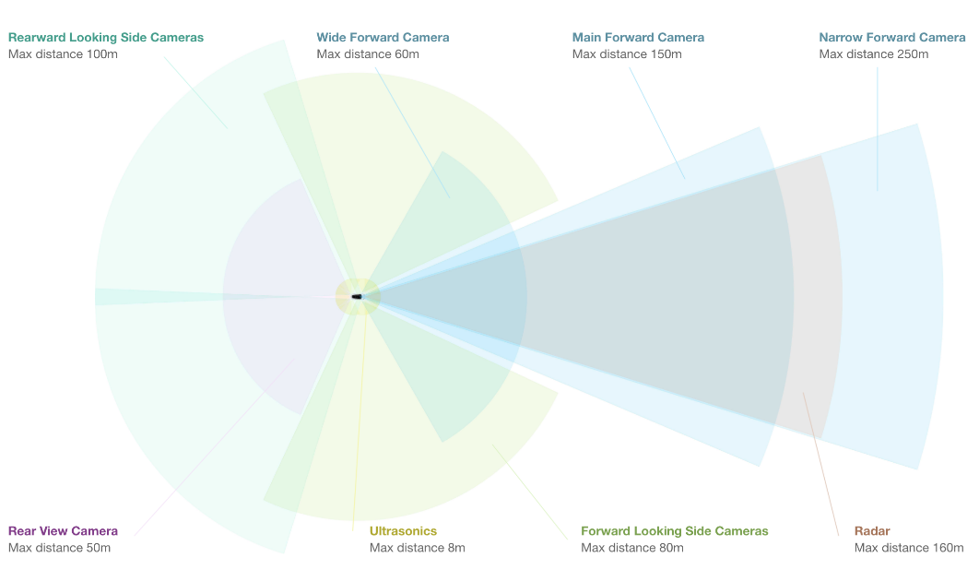

Let us look at each sensor type in turn:

* *Cameras* : The forward-facing optical array consists of four cameras with differing focal lengths. The narrow-forward camera captures footage up until 250m in front, the forward camera with a slightly larger opening angle looks up until 150m in front, a wide-angle camera that captures 60m in front, and a set of forward-looking side cameras that capture footage 80m in front and to the side of the car. The wide-angle camera is designed to read road signs and traffic lights, allowing the car to react accordingly. It is debated however, whether this feature can be reliably used in traffic.
* *Radar* : The forward-looking radar can see up to 160m ahead of the car. According to Tesla founder Elon Musk it is able to see through "sand, snow, fog—almost anything".
* *Sonar* : A 360° ultrasonic sonar detects obstacles in an eight-meter radius around the car. The ultrasonic sensors work at any speed and are used to spot objects in close proximity of the car. The ultrasonic sensors can also be used to assist the car when automatically switching lanes. Their range however, compared to the other sensors of the set, is significantly limited and ends at about 8 meters distance.

As you may have noticed, Tesla is not using a Lidar sensor despite its plans to offer level 4 or even level 5 autonomous driving with this setup. Unlike many other manufacturers who aim at full autonomy such as Uber, Waymo and several others, Tesla is convinced that a set of high-performance cameras coupled with a powerful radar sensor will be sufficient for level 4 / level 5 autonomy. At the time of writing, there is a fierce debate going on about the best sensor set of autonomous vehicles. Tesla argues that the price and packaging disadvantage of Lidar would make the Autopilot unattractive to customers. Harsh critics such as GM's director of autonomous vehicle integration Scott Miller disagrees and argues with the highly elevated safety requirements of autonomous vehicles, which would not be met with cameras and radar alone.

Is has to be noted however that in all sensor setups, be it Uber, Tesla, Waymo or traditional manufacturers such as Mercedes or Audi, cameras are always used. Even though there is an ongoing debate on wether radar or Lidar or a combination of the two would be best, cameras are never in question. It is therefore a good idea to learn about cameras and computer vision, which we will do in great detail in this course.

**Sensor Selection Criteria**

The design of an autonomous or ADAS-equipped vehicle involves the selection of a suitable sensor set. As you have learned in the preceding section, there is a discussion going on about which combination of sensors would be necessary to reach full (or even partial) autonomy. In this section, you will learn about sensor selection criteria as well as the differences between camera, Lidar and radar with respect to each criterion.

In the following, the most typical selection criteria are briefly discussed.

1. **Range** : Lidar and radar systems can detect objects at distances ranging from a few meters to more than 200m. Many Lidar systems have difficulties detecting objects at very close distances, whereas radar can detect objects from less than a meter, depending on the system type (either long, mid or short range) . Mono cameras are not able to reliably measure metric distance to object - this is only possible by making some assumptions about the nature of the world (e.g. planar road surface). Stereo cameras on the other hand can measure distance, but only up to a distance of approx. 80m with accuracy deteriorating significantly from there.
2. **Spatial** **resolution** : Lidar scans have a spatial resolution in the order of 0.1° due to the short wavelength of the emitted IR laser light . This allows for high-resolution 3D scans and thus characterization of objects in a scene. Radar on the other hand can not resolve small features very well, especially as distances increase. The spatial resolution of camera systems is defined by the optics, by the pixel size on the image and by its signal-to-noise ratio. Details on small object are lost as soon as the light rays emanating from them are spread to several pixels on the image sensor (blurring). Also, when little ambient light exists to illuminate objects, spatial resolution increases as objects details are superimposed by increasing noise levels of the imager.
3. **Robustness** **in** **darkness** : Both radar and Lidar have an excellent robustness in darkness, as they are both active sensors. While daytime performance of Lidar systems is very good, they have an even better performance at night because there is no ambient sunlight that might interfere with the detection of IR laser reflections. Cameras on the other hand have a very reduced detection capability at night, as they are passive sensors that rely on ambient light. Even though there have been advances in night time performance of image sensors, they have the lowest performance among the three sensor types.
4. **Robustness** **in** **rain,** **snow,** **fog** : One of the biggest benefits of radar sensors is their performance under adverse weather conditions. They are not significantly affected by snow, heavy rain or any other obstruction in the air such as fog or sand particles. As an optical system, Lidar and camera are susceptible to adverse weather and its performance usually degrades significantly with increasing levels of adversity.
5. **Classification** **of** **objects** : Cameras excel at classifying objects such as vehicles, pedestrians, speed signs and many others. This is one of the prime advantage of camera systems and recent advances in AI emphasize this even stronger. Lidar scans with their high-density 3D point clouds also allow for a certain level of classification, albeit with less object diversity than cameras. Radar systems do not allow for much object classification.
6. **Perceiving** **2D** **structures** : Camera systems are the only sensor able to interpret two-dimensional information such as speed signs, lane markings or traffic lights, as they are able to measure both color and light intensity. This is the primary advantage of cameras over the other sensor types.
7. **Measure** **speed** : Radar can directly measure the velocity of objects by exploiting the Doppler frequency shift. This is one of the primary advantages of radar sensors. Lidar can only approximate speed by using successive distance measurements, which makes it less accurate in this regard. Cameras, even though they are not able to measure distance, can measure time to collision by observing the displacement of objects on the image plane. This property will be used later in this course.
8. **System** **cost** : Radar systems have been widely used in the automotive industry in recent years with current systems being highly compact and affordable. The same holds for mono cameras, which have a price well below US$100 in most cases. Stereo cameras are more expensive due to the increased hardware cost and the significantly lower number of units in the market. Lidar has gained popularity over the last years, especially in the automotive industry. Due to technological advances, its cost has dropped from more than US$75,000 to below US$5,000. Many experts predict that the cost of a Lidar module might drop to less than US$500 over the next years.
9. **Package** **size** : Both radar and mono cameras can be integrated very well into vehicles. Stereo cameras are in some cases bulky, which makes it harder to integrate them behind the windshield as they sometimes may restrict the driver's field of vision. Lidar systems exist in various sizes. The 360° scanning Lidar is typically mounted on top of the roof and is thus very well visible. The industry shift towards much smaller solid-state Lidar systems will dramatically shrink the system size of Lidar sensors in the very near future.
10. **Computational** **requirements** : Lidar and radar require little back-end processing. While cameras are a cost-efficient and easily available sensor, they require significant processing to extract useful information from the images, which adds to the overall system cost.

### Camera Technology Overview

In this section you will learn about the basic properties of a camera. We will start from the most basic model called a „pinhole camera“ and then progress to using lenses, which are a key component of camera systems. You need this knowledge in order to understand how a camera creates images, which of its properties influence image appearance and quality and which parameters you have to consider in order to successfully extract meaningful information from these images.

**The Pinhole Camera**

A very simple camera can be designed by placing a light barrier with a tiny opening (the pinhole) between an object of interest. The light emitted by the object passes through the pinhole and lands on a photosensitive surface which stores the light information as an image. The reason why the pinhole has been made so small is to avoid image blurring due to superimposing rays of light stemming from various parts of the object of interest.

This simple principle has been well known for centuries and was for example used by artists to create photorealistic portraits.

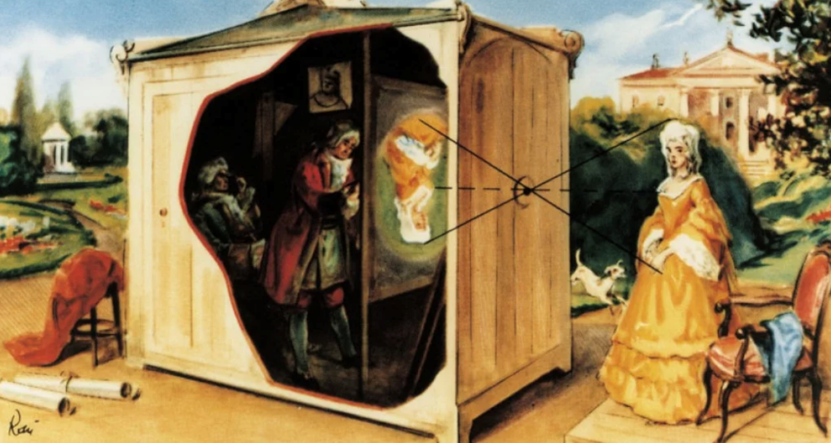

A formal model of the pinhole camera model is shown below:

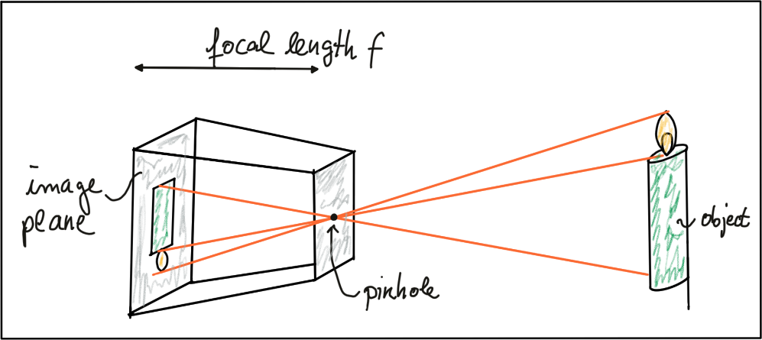

The photosensitive surface on the left is called the *image plane* whereas the pinhole is called the *camera center*. The distance between the camera center and the image plane is called the *focal length f*.

A point P on the object of interest can be mapped to a point P’ on the image plane by casting a beam through the center of projection until it hits the image plane as shown in the figure below.

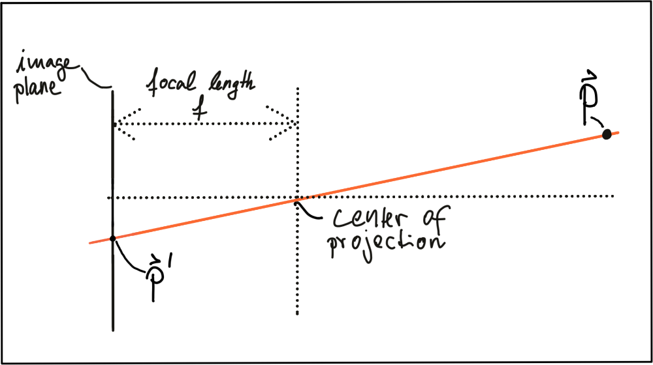

In three-dimensional space, the relation between $P$ and $P^{'}$ is expressed by the following equations:

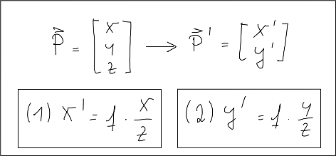

Based on these equations, we are able to compute the 2D position of an object on the image plane, given the 3D position of the object in space as well as the focal length of the camera. Note however that the resulting coordinates x’ and y’ are metrical coordinates and not pixel positions yet.

The problem with pinhole cameras is that the amount of light passing through the pinhole is not sufficient to generate a decent image on an image sensor. If one were to increase the amount of light by widening the pinhole opening as shown in the figure below, rays of light from other parts of the object of interest would superimpose each other, leading to a blurring effect: The larger the pinhole, the brighter the image but at the same time, the more severe the blurring of the object on the image plane would be.

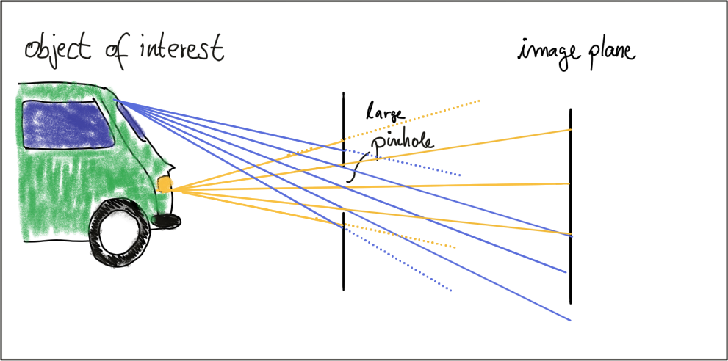

One way to solve this problem is use a lens, which is able to capture multiple rays of light that emanate from the same point on the object of interest. So let’s look at lenses next.

**Lenses and Apertures**

A properly sized and positioned lens refracts all rays of light that emanate from a point $P_{1}$ on an object in space such that they converge to a single point $p_{1}^{'}$ in the image plane. Rays of light passing through the lens center are not refracted however, they continue on as a straight line until they intersect the image plane.

Points on the object that are closer or farther away, such as $P_{2}$ appear out of focus on the image plane, because the set of light rays emanating from them does not converge in a point but rather in a circle with a finite radius instead. This blurry circle is usually referred to as circle of confusion (COF). To reduce blurring, an aperture can be used, which is a concentric opening of usually adjustable size placed directly behind the lens. The following figure illustrates the principle:

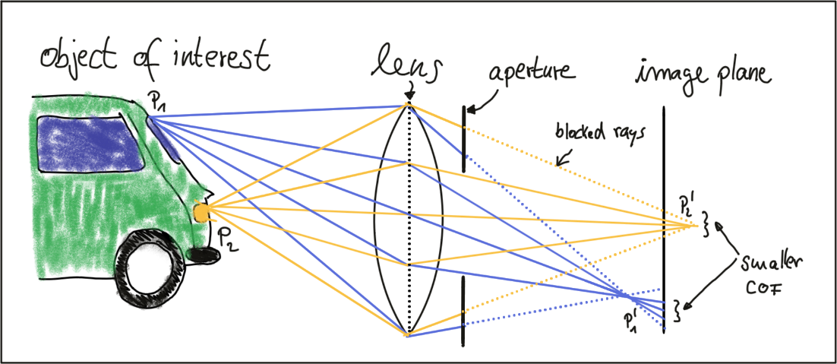

By reducing the diameter of the aperture, light rays passing through the lens on the outer edges are blocked, which reduces the size of the COF on the image plane. It can easily be seen that a smaller aperture results in reduced blurring, but at the expense of low light sensitivity. The larger the aperture, the more light rays are focused onto the image area, resulting in brighter images with a better signal-to-noise ratio.

So how can we compute where an object in space will appear in the image? Given a 3D point in space, its 2D position on the image plane after passing through a lens can be computed similar to the pinhole camera. In practice, lenses introduce distortion into images, depending on the lens type. The distortion most relevant to practice is called “radial distortion”. It is caused by the focal length of the lens not being uniform over its diameter. Therefore, the magnification effect of the lens changes depending on the distance between the camera center (the optical axis) and the ray of light passing through the lens. If the magnification increases the resulting distortion effect is called ‚pin cushion distortion‘. It decreases, it is called ‚barrel distortion‘ instead. Barrel distortions usually occur, when wide-angle lenses are used. In the figure below, both distortion types are illustrated.

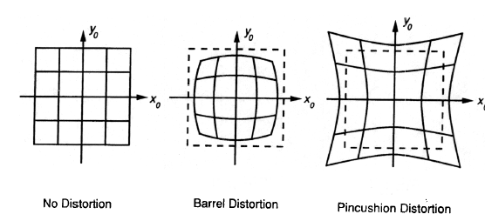

When extracting information from camera images, many applications seek to draw conclusions on the spatial location of objects of interest (e.g. vehicles). To get there, the distortion effect of the lens must be removed or at least mitigated. The relevant process is called calibration. For each camera-lens-setup, a calibration procedure must be performed so the distortion parameters can be individually computed. This is usually done by taking a set of pictures of well-known objects such as planar checkerboard patterns, from whose known geometry all lens and image sensor parameters can be robustly derived. The process of removing distortions from a camera image is called rectification. In the image below, the calibration setup used to rectify most of the images in this course is shown. It can easily be seen that lines at both left and right are distorted significantly.

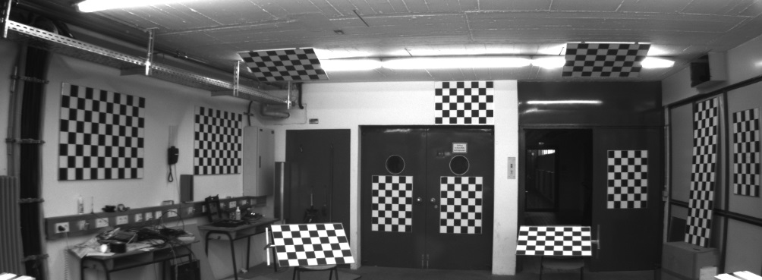

It is beyond the scope of this course however to go into the details of distortion correction. Most of the images you will be using are already free of lens distortion. When using your own camera setup however, a calibration procedure must be performed when precise measurements and a spatial reconstruction of objects is the goal.

As mentioned before, the projection of points in 3D space onto the image plane does not directly correspond to what we see in actual digital images, which are made up of thousands of picture elements or pixels. To understand how images can be expressed in discrete pixels, we need to take a closer look at the above-mentioned camera model once more. In the figure below, the camera center is shown with a position $O$ in space along with its own coordinate system with axes $i$, $j$ and $k$, where $k$ is pointing into the direction of the image plane. The position $C^{'}$

where $k$ intersects the image plane is called the principal point and represents the center of the image coordinate system.

The first step after projecting a point $P$ in space onto the image plane is thus to subtract the principal point coordinates so that the discrete image has its own coordinate system centered in e.g. the lower left corner of the image plane

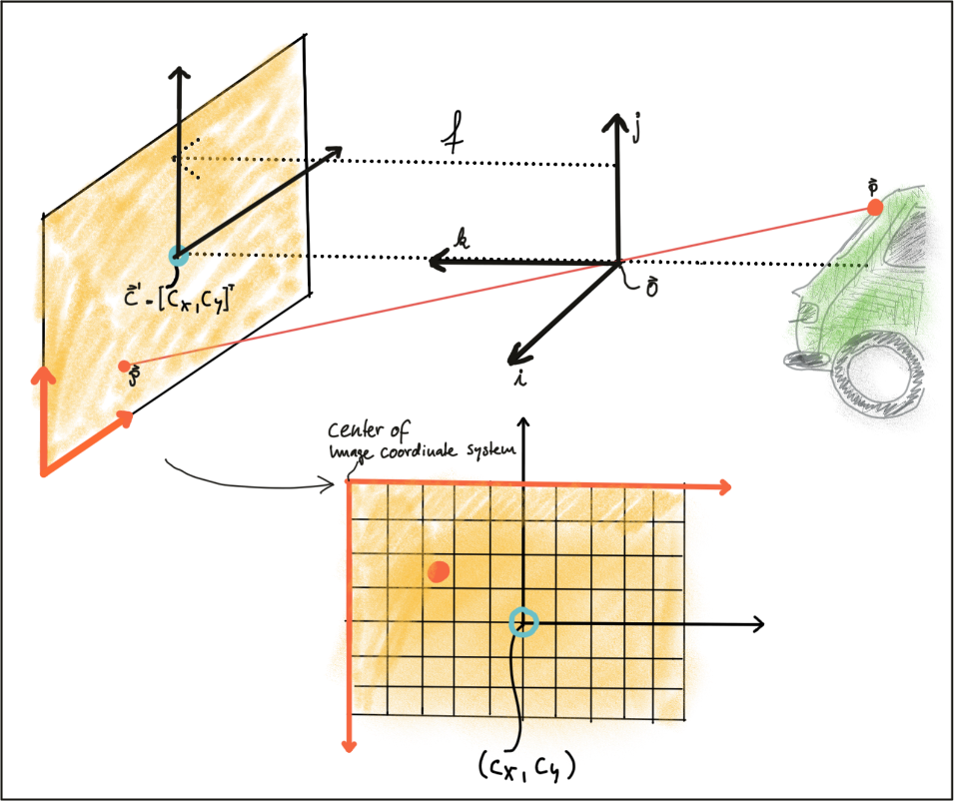

The second step in the transformation process is to move from metric to pixel coordinates. To do so, we can use parameters $k$ and $l$ provided by the calibration procedure which convert meters to pixels and which can be easily integrated into the projection equations as seen below. Note that in image coordinates, the y-axis has its origin in the upper-left corner and is pointing downwards.

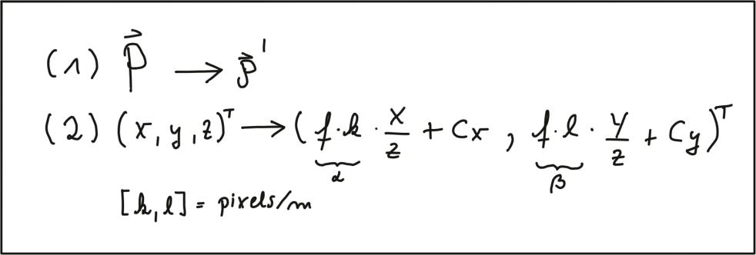

In a later section of this course, we will be mapping Lidar 3D points into the camera image. To do so, we will make use of these equations. Specifically, the product of focal width $f$ and $k$ and $l$ respectively (also termed alpha and beta) will be used in a calibration matrix to simplify the mapping operation significantly.

One final note on image rectification: In many applications (e.g. feature tracking) it makes sense to process the original image to avoid interpolation errors when the rectified image is computed and transformed pixels do not fall exactly onto the center of a discrete pixel in the rectified image but close to the border to another pixel instead. In such a case, it is advisable to locate the features in the unmodified original image and then transform the resulting coordinates using the equations above. When using deep learning based on a set of trained weights, it makes sense to rectify the image first before feeding it to a network - if we would use the original image, distortions (such as from a fish-eye lens) would lead to detection errors as networks are usually trained on a distortion-free image set.

**Imagers and Bayer Pattern**

In this last section, you will learn how rays of light with a certain wavelength are converted into color pixels that can be stored digitally.

When an image is captured by a camera, light passes through the lens and falls on the image sensor. This sensor consists of light sensitive elements that register the amount of light that falls on them and convert it into a corresponding number of electrons. The more light, the more electrons are generated. Once the exposure time is complete, the generated electrons are converted into a voltage, which is finally transformed into a discrete number by means of an A/D-converter.

Currently, there are two main image technologies, which are CCD (Charge-Coupled Device) and CMOS (Complementary Metal-oxide Semiconductor). Both technologies convert electrons into voltage and are inherently color blind, as they cannot distinguish the different wavelengths which generate the electrons. To enable color vision, tiny filter elements (also micro-lenses) are placed in front of each pixel which only allow a certain wavelength to pass through. One common way to map wavelength to color is to arrange the filter elements in an RGB (Red, Green, Blue) pattern to allow the primary colors to pass through individually, which gives us three individual images - one for each primary color.

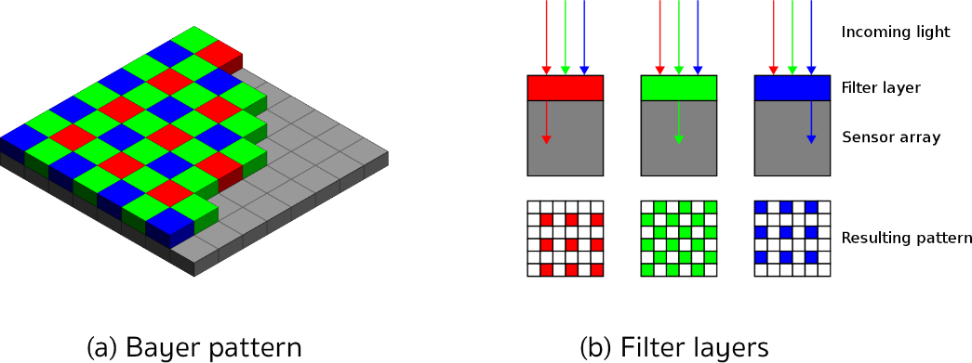

Mixed in different combinations, RGB values can produce most of the colors visible to the human eye. When each discrete color value is coded with 8bits (i.e. 256 values), a total of 16.7 million different colors can be created with the RGB filter concept. The most common way of arranging the RGB filters is called a Bayer pattern, which has alternating rows of red-green and green-blue filters. Since the human eye is more sensitive to green than to red or blue, the Bayer array has twice as many green color filters. When processing color images in a computer vision application, all three RGB layers are available and it has to be decided which color layers to use. If processing power is limited, the different channels are combined into a gray scale image. In the upcoming section on computer vision, you will be introduced to the OpenCV computer vision library.

**CCD vs CMOS**

In a CCD sensor, the electrons collected in each picture element are transferred from the chip through a single or only a few output nodes. The charges are then converted to voltage levels, buffered, and sent out as an analog signal. This signal is then amplified and converted to discrete numbers using an A/D-converter outside the sensor. Originally, CCD technology has had several advantages compared to CMOS, such as higher light sensitivity and less noise. In recent years, however, these differences have all but disappeared. The major disadvantages of CCD are a higher production price and a higher power consumption (up to 100x more than CMOS) , which usually leads to heat issues in the camera.

CMOS sensors were originally used for machine vision applications, but the image quality was poor due to their inferior light sensitivity. With modern CMOS sensors however, both quality and light sensitivity have significantly increased. The CMOS technology has several advantages: Unlike CCD, CMOS chips incorporate amplifiers and A/D-converters, which brings a huge cost advantage. With CCD, those components are located outside of the chip. CMOS sensors also have a faster data readout, lower power consumption, higher noise immunity, and a smaller system size. In automotive applications, almost all cameras use CMOS sensors because of these advantages

### The OpenCV Computer Vision Library

Throughout this course, you will be using the OpenCV, which is a cross-platform computer vision library which was originally developed in the year 2000 to provide a common infrastructure for computer vision applications and to accelerate the use of machine vision in science and engineering projects. Originally founded by Intel, the open-source library is now supported by several companies and hundreds of experts all over the globe.



The library has more than 2500 algorithms that can be used to detect and recognize faces, identify objects, classify human actions in videos, track camera movements, track moving objects, perform machine learning and many more. OpenCV is written natively in C++ but has interfaces to Python, Java and Matlab as well. In this course, you will be using the C++ version of OpenCV.

The major advantage in using the OpenCV library is that you will be able to leverage a well-tested set of state-of-the-art computer vision algorithms. Without having to concentrate on the actual implementation of computer vision concepts such as Sobel operators, keypoint detection or machine learning you can use them right out of the box and concentrate on combining them in the right way to develop a working software prototype. Despite this ease of use however, a good understanding of the theories behind those concepts is needed to use them correctly.

In the following, you will familiarize yourself with some basic concepts you will need to get started with OpenCV and to prepare yourself for the more advanced lessons later in the course. The libraries listed below will be used extensively throughout this lecture. They are however only a small part of the entire OpenCV. Later, you will also include some specialized libraries such as flann (Fast Library for Approximate Nearest Neighbors) or dnn (Deep Neural Networks), which will be described only in those sections of this course where they are used.

A note on namespaces: Most OpenCV functions exist within the _cv_ namespace. Usually, to shorten the code, the using namespace cv command is used in many applications. In this course however, this is not done to make it clear when we are using function calls from the OpenCV.

**OpenCV Library Overview**

The core module is the section of the library that contains all of the basic object types and their operations. To use the library in your code, the following header has to be included:

#include "opencv2/core/core.hpp"

The highgui module contains user interface functions that can be used to display images or take simple user input. To use the library in your code, the following header has to be included:

#include "opencv2/highgui/highgui.hpp"

In this project, basic functions such as cv::imshow will be used to display images in a window.

The imgproc (image processing) module contains basic transformations on images, such as image filtering, geometric transformations, feature detection and tracking. To use the library in your code, the following header has to be included:

#include "opencv2/imgproc/imgproc.hpp"

The features2d module contains algorithms for detecting, describing, and matching keypoints between images. To use the library in your code, the following header has to be included:

#include "opencv2/features2d/features2d.hpp"

* + 1. Placeholder

## Engineering a Collision Detection System

### Collision Detection Basics

**The Collision Detection Problem**

A collision avoidance system (CAS) is an active safety feature that warns drivers or even triggers the brake in the event of an imminent collision with an object in the path of driving. If a preceding vehicle is present, the CAS continuously estimates the time-to-collision (TTC). When the TTC falls below a lower threshold, the CAS can then decide to either warn the driver of the imminent danger or - depending on the system - apply the vehicle brakes autonomously. For the engineering task you will be completing in this course this means that you will need to find a way to compute the TTC to the vehicle in front.

Let us take a look at the following scene:

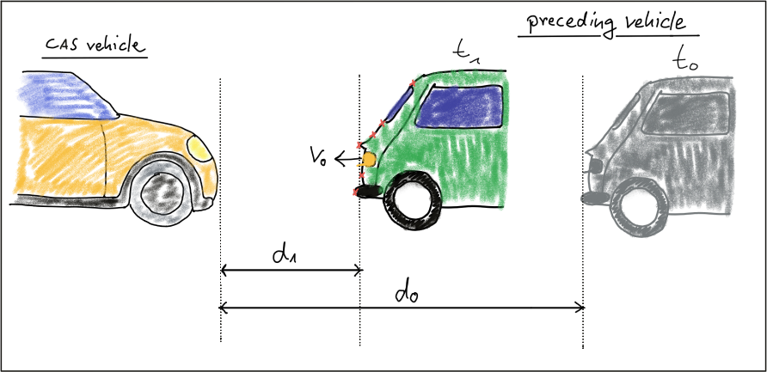

In this traffic scenario, the green vehicle starts to reduce its speed at time $t_{0}$, which is when the yellow vehicle, equipped with a collision sensor, takes the distance measurement $d_{0}$. A moment later, at time $t_{1}$, the green vehicle is considerably closer and a second measurement $d_{1}$ is taken. The goal now is to compute the remaining TTC so the system can warn the driver of the yellow vehicle or even trigger the brakes autonomously.

Before we can do this however, we need to find a way to describe the relative motion of the vehicles with a mathematical model.

**Constant Velocity vs. Constant Acceleration**

To compute the TTC, we need to make assumptions on the physical behavior of the preceding vehicle. One assumption could be that the relative velocity between the yellow and green vehicle in the above figure were constant. This would lead to the so-called constant velocity model (CVM) which is represented by eq. 1 in the following diagram.

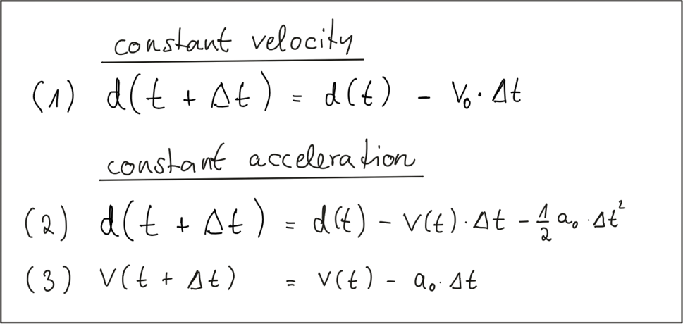

As you can see, the distance to the vehicle at time instant $t+ Δt$ is smaller than at time $t$, because we subtract the product of a constant relative velocity $v_{0}$ and time $Δt$. From an engineering perspective, we would need a sensor capable of measuring the distance to the preceeding vehicle on a precisely times basis with a constant dt between measurements. This could very well be achieved with e.g. a Lidar sensor.

Especially in dynamic traffic situations where a vehicle is braking hard, the CVM is not accurate enough however, as the relative velocity between both vehicles changes between measurements. In the following figure, the approaching vehicle is shown at three time instants with increasing velocity.

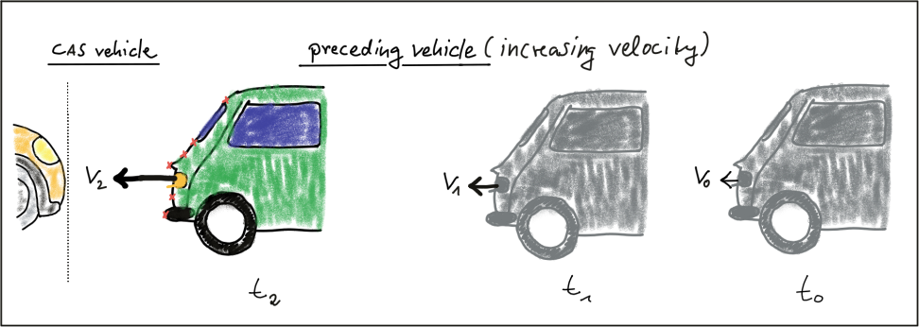

We can thus expand on our CVM by assuming velocity to be a function of time and subtract a second term in eq. 2 which is the product of a constant acceleration and the squared time dt between both measurements. Eq. 3 displays velocity as a function of time, which is also dependent on the constant acceleration we used in eq. 2. This model is referred to as constant acceleration model (CAM) and it is commonly used in commercially available collision detection systems. On a side note, if we were using a radar sensor instead of a Lidar, a direct measurement on velocity could be taken by exploiting a frequency shift in the returning electromagnetic wave due to the Doppler effect. This is a significant advantage over sensors such as Lidar, where velocity can only be computed based on (noisy) distance measurements.

In this course, we will be using a CVM instead of the CAM as it is much simpler to handle with regard to the math involved and with regard to the complexity of the programming task ahead of you. For small instances of dt we will assume that the CVM model is accurate enough and that it will give us a decent estimate of the TTC. Should you be involved in building a commercial version of such a system at a later stage in your career however, keep in mind that you should be using a constant acceleration model instead.

### Estimating TTC with Lidar

**The Math Behind Time-To-Collision**

In the following, let us assume that our CAS-equipped vehicle is using a Lidar sensor to take distance measurements on preceding vehicles. The sensor in this scenario will give us the distance to the closest 3D point in the path of driving. In the figure below, the closest point is indicated by a red line emanating from a Lidar sensor on top of the CAS vehicle.

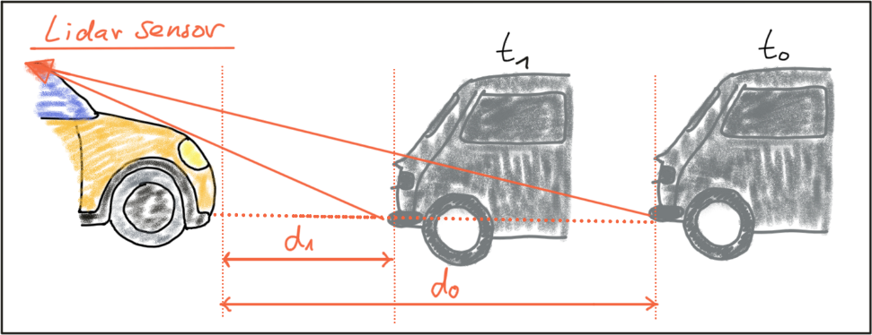

Based on the model of a constant-velocity we discussed in the last section, the velocity $v_{0}$ can be computed from two successive Lidar measurements as follows:

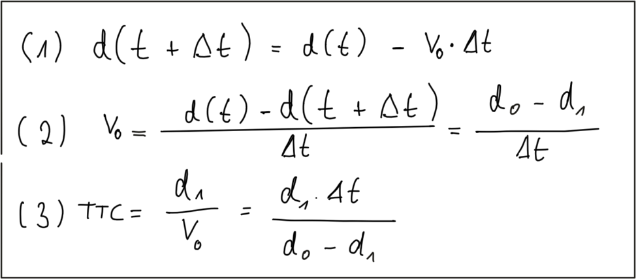

Once the relative velocity $v_{0}$ is known, the time to collision can easily be computed by dividing the remaining distance between both vehicles by $v_{0}$. So given a Lidar sensor which is able to take precise distance measurements, a system for TTC estimation can be developed based based on a CVM and on the set of equations shown above. Note however that a radar sensor would be the superior solution for TTC computation as it can directly measure the relative speed, whereas with the Lidar sensor we need to compute $v_{0}$ from two (noisy) distance measurements.

**Preparing the Lidar Point Cloud**

The following image shows a Lidar point cloud as an overlay over a camera image taken in a highway scenario with a preceding vehicle directly in the path of driving. Distance to the sensor is color-coded (green is far away, red is close). On the left side, a bird-view perspective of the Lidar points is shown as well.

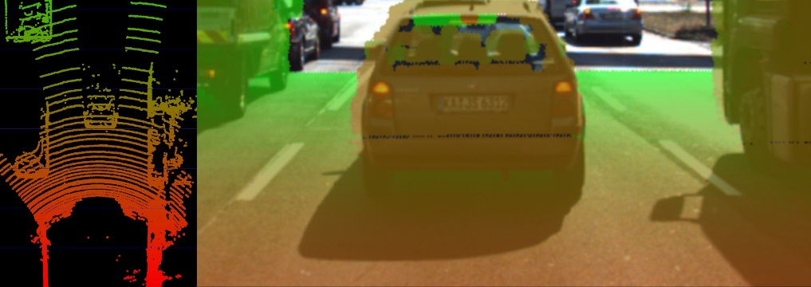

As can easily be seen, the Lidar sensor provides measurements on the vehicles as well as on the road surface. Also, some 3D points in the camera image do not seem accurate when compared to their surrounding neighbors. Especially the points near the roof of the preceding vehicle differ in color from the points on the tailgate.

As measurement accuracy is correlated to the amount of light reflected from an object, it makes sense to consider the reflectiveness r of each Lidar point which we can access in addition to the x, y and z coordinates. The image below highlights high reflectiveness with green, whereas regions with low reflectiveness are shown as red. An analysis of the associated reflectivity of the point cloud shows that such deviations often occur in regions with reduced reflectiveness.

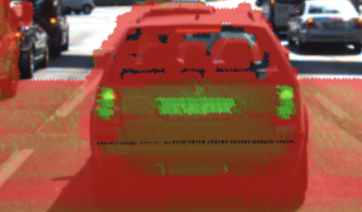

In order to derive a stable TTC measurement from the given point cloud, two main steps have to be performed:

* Remove measurements on the road surface
* Remove measurements with low reflectivity

In the figure below, Lidar points are shown in a top-view perspective and as an image overlay after applying the filtering. After removing Lidar points in this manner, it is now much easier to derive the distance d(t) to the preceding vehicle.

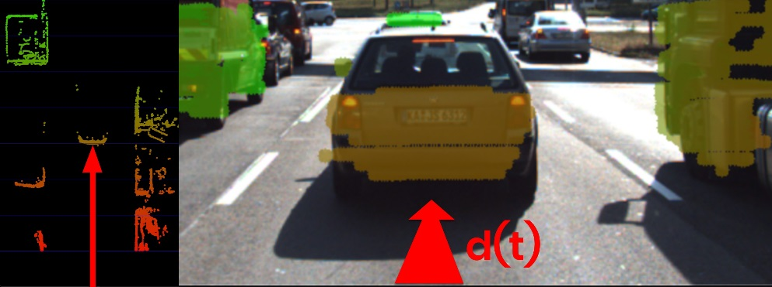

In a later lesson, you will learn how to project Lidar points into the camera image and how to perform the removal procedure as seen in the above examples. For now, let us assume that for each time step dt, the Lidar sensor would return the distance d(t+dt) to the preceding vehicle.

**Computing TTC from Distance Measurements**

In the code examples in this course, Lidar points are packaged into a data structure called LidarPoints. As seen below, the structure consists of the point coordinates x (forward), y (left) an z (up) in metric coordinates and of the point reflectivity r on a scale between 0 and 1 (high reflectivity).

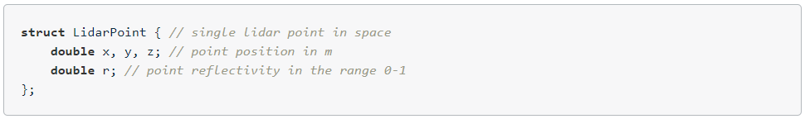

In order to compute the TTC, we need to find the distance to the closest Lidar point in the path of driving. In the figure below, Lidar measurements located on the tailgate of the preceding vehicle are measured at times $t_{0}$ (green) and $t_{1}$ (red). It can be seen, that the distance to the vehicle has decreased slightly between both time instants.

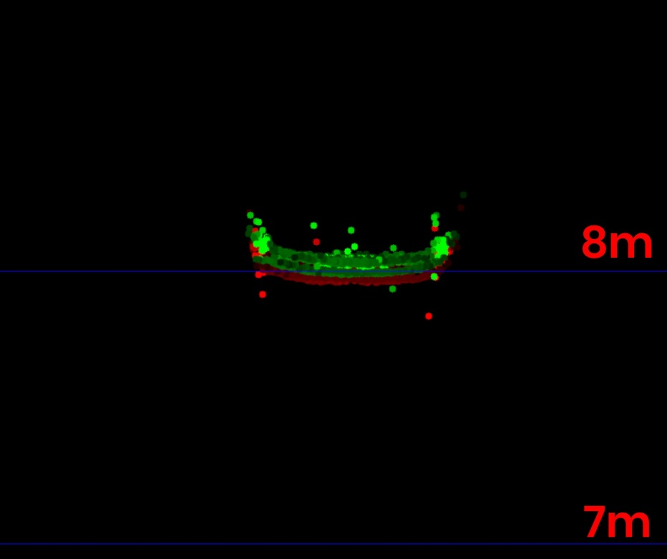

The following code searches for the closest point in the point cloud associated with $t_{0}$ (lidarPointsPrev) and in the point cloud associated with $t_{1}$ (lidarPointsCurr). After finding the distance to the closest points respectively, the TTC is computed based on the formula we derived at the beginning of this section.

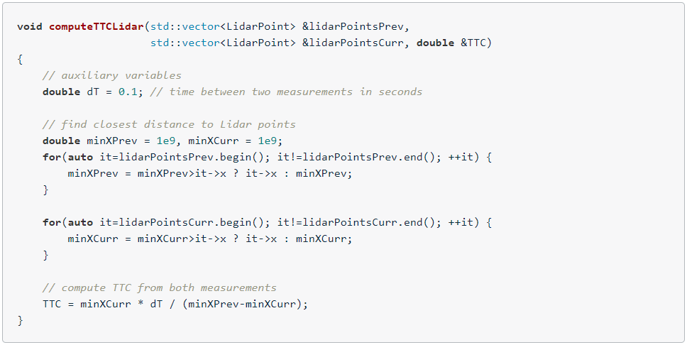

Even though Lidar is a reliable sensor, erroneous measurements may still occur. As seen in the figure above, a small number of points is located behind the tailgate, seemingly without connection to the vehicle. When searching for the closest points, such measurements will pose a problem as the estimated distance will be too small. There are ways to avoid such errors by post-processing the point cloud, but there will be no guarantee that such problems will never occur in practice. It is thus a good idea to perform a more robust computation of minXCurr and minXPrev which is able to cope with a certain number of outliers (in the final project, you will do this) and also look at a second sensor which is able to compute the TTC, such as the camera.

### Estimating TTC with Camera

**Measuring TTC without distance**

Monocular cameras are not able to measure metric distances. They are passive sensors that rely on the ambient light which reflects off of objects into the camera lens. It is thus not possible to measure the runtime of light as with Lidar technology.

To measure distance, a second camera would be needed. Given two images taken by two carefully aligned cameras (also called a stereo setup) at the same time instant, one would have to locate common points of interest in both images (e.g. the tail lights of the preceding vehicle) and then triangulate their distance using camera geometry and perspective projection. For many years, automotive researchers have developed stereo cameras for the use in ADAS products and some of those have made it to market. Especially Mercedes-Benz has pioneered this technology and extensive information can be found here : http://www.6d-vision.com/. With more advanced ADAS products and with autonomous vehicles however, stereo cameras have started to disappear from the market due to their package size, the high price and the high computational load for finding corresponding features.

Despite those limitations of the mono camera, let us see if there is a way to compute TTC without the need to measure distance. Let us consider the constant velocity motion model we introduced in a previous section of this course and think about a way to replace the metric distances d with something the camera can measure reliably, such as pixel distances directly on the image plane. In the following figure, you can see how the height $H$ of the preceding vehicle can be mapped onto the image place using perspective projection. We can see that the same height $H$ maps to different heights $h_{0}$ and $h_{1}$ in the image plane, depending on the distance $d$ and $d_{1}$ of the vehicle. It is obvious that there is a geometric relation between $h$, $H$, $d$ and the focal length $f$ of the pinhole camera - and this is what we want to exploit in the following.

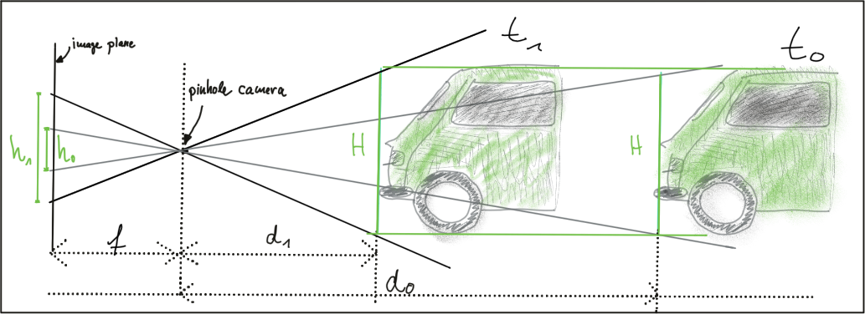

Let us take a look at the following set of equations:

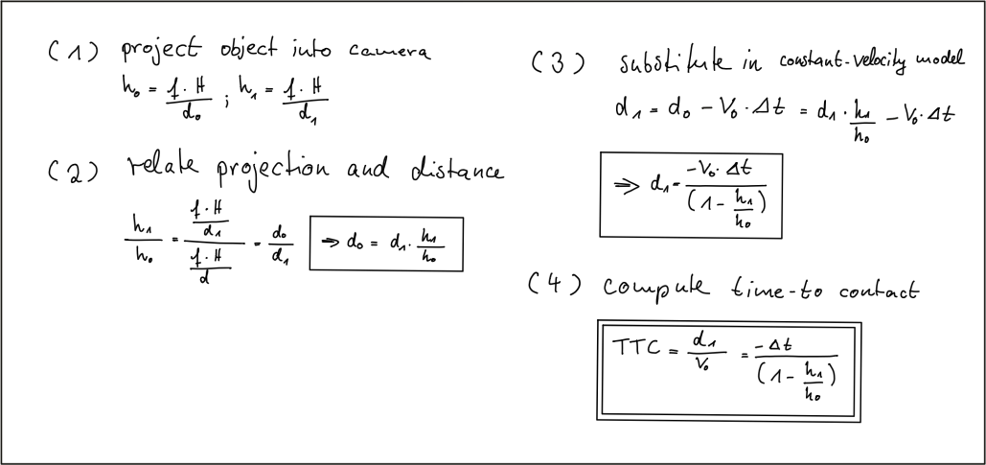

In (1) we use the focal length of the camera and a distance measurement $d_{0}$ performed at time $t_{0}$ to project the height $H$ of the vehicle onto the image plane and thus to a height $h_{0}$ in pixels. The same is done at time $t_{1}$, leading to a projected height $h_{1}.$

In (2), we compute the ratio of the relative heights $h_{0}$ and $h_{1}$. As both $H$ and $f$ are cancelled out, we can observe a direct relation between relative height $h$ and absolute metric distance $d$. We can thus express the distance to the vehicle $d_{0}$ as the product of $d_{1}$ and the ratio of relative heights on the image plane.

In (3), we substitute $d_{0}$ in the equation for constant velocity and solve for $d_{1}$, which is now dependent on the constant relative velocity $v_{0}$, on the time between measuring $d_{0}$ and $d_{1}$ and on the ratio of relative heights on the image plane.

In (4), the TTC is computed as the ratio of remaining distance to impact, which is $d_{1}$, and the constant velocity $v_{0}$. As we can easily see, the TTC now only consists of $Δt$, $h_{0}$ and $h_{1}$. Thus, it is possible to measure the time to collision by observing relative height change on the image sensor. Distance measurements are not needed and we can thus use a mono camera to estimate the time-to-collision by observing changes in relative height (also called scale change) directly in the image.

**The problem with bounding Box Detection**

In the figure below, a neural network has been used to locate vehicles in successive images of a monocular camera. For each vehicle, the network returns a bounding box, whose width and/or height could in principal be used to compute the height ratio in the TTC equation we derived in the last section.

When observed closely however, it can be seen that the bounding boxes do not always reflect the true vehicle dimensions and the aspect ratio differs between images. Using bounding box height or width for TTC computation would thus lead to significant estimation errors.

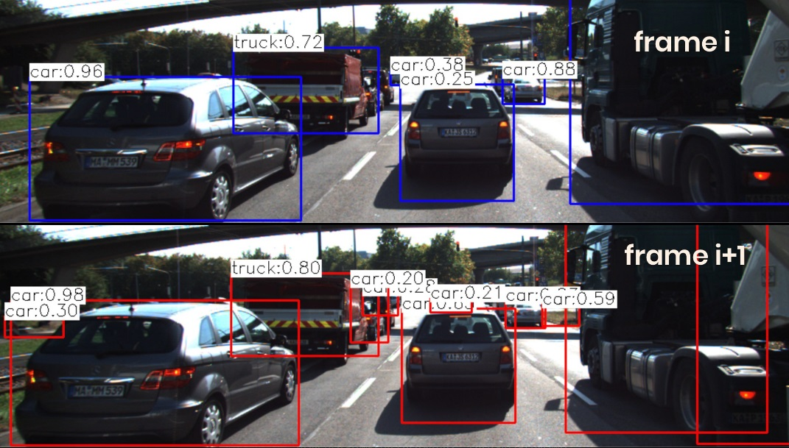

In most engineering tasks, relying on a single measurement or property is not reliable enough. This holds especially true for safety-related products. Therefore, we want to consider whether there are further properties of vehicles and objects we can observe in an image.

**Using Texture Keypoints Instead**

Instead of relying on the detection of the vehicle as a whole we now want to analyze its structure on a smaller scale. If if were possible to locate uniquely identifiable keypoints that could be tracked from one frame to the next, we could use the distance between all keypoints on the vehicle relative to each other to compute a robust estimate of the height ratio in out TTC equation. The following figure illustrates the concept.

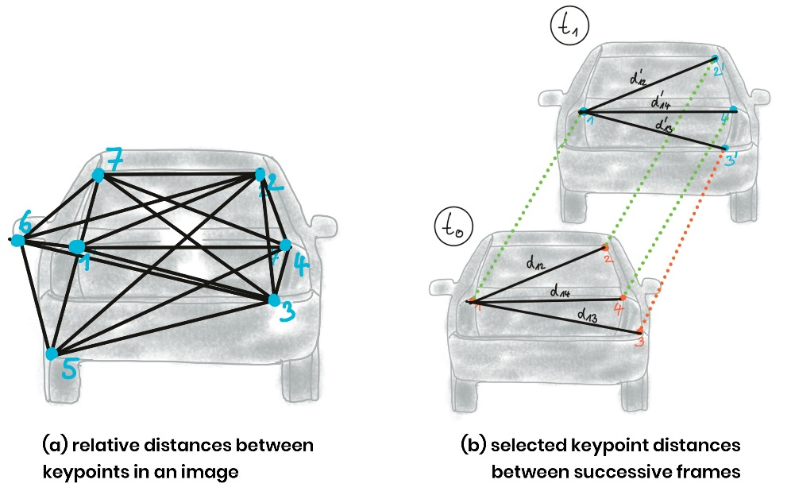

In (a), a set of keypoints has been detected and the relative distances between keypoints 1-7 have been computed. In (b), 4 keypoints have been matched between successive images (with keypoint 3 being a mismatch) using a higher-dimensional similarity measure called descriptor (more about that in the next lesson). The ratio of all relative distances between each other can be used to compute a reliable TTC estimate by replacing the height ratio ${h_{1}}/{h_{0}}$ with the mean or median of all distance ratios ${d_{k}}/{d_{k}^{'}}$.

The following figure shows several example of relative distances between keypoints as an overlay over a highway driving scene (only the preceding vehicle is highlighted).

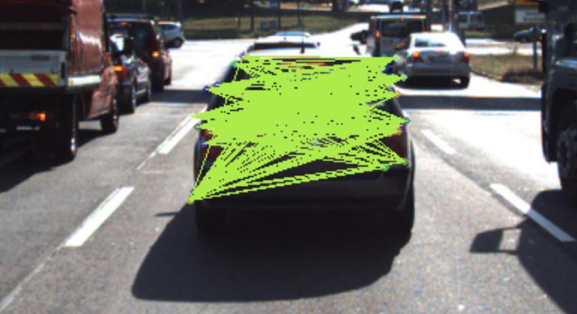

### Course Structure

### 3.2.5 Early Fusion vs. Late Fusion

### 3.2.2 Placeholder

## Tracking Image Features

### Heading 1

### 3.3.2 Placeholder

## Camera Based 2D Feature Tracking

### Heading 1

### 3.4.2 Placeholder

## Combing Camera and Lidar

### Heading 1

### 3.5.2 Placeholder

## Track an Object in 3D Space

### Heading 1

### 3.5.2 Placeholder

## 3.7 Placeholder

### 

### 

<https://classroom.udacity.com/nanodegrees/nd313-beta/parts/45d2275b-5183-4d45-84d9-50d113be93cb/modules/b52e21b1-f7ef-434a-9378-58b75dfa6800/lessons/7fb8e8ec-0246-4e1e-9d12-e3cdf11391b7/concepts/38df3cda-6708-40e8-b9e0-347d02339007>